Advance Data Science

LOAN LENDING CLUB

Assignment – 3 Part - 1

Report by:

Ankit Bhayani

Rajat Agrawal

Vaisakha Sawant

The report summarizes the design and implementation of the data wrangling performed on the Loan Lending club data set. This report is divided into three section.

**OBJECTIVE**

**Section 1**: Describes the step by step implementation of downloading the dataset provided on the website by the Loan Lending club and preprocessing the data.

**Section 2**: Describes the step by step process to clean the downloaded file and apply feature engineering technique to predict interest rate.

**Section 3**: Describe the implementation to streamline the process using Luigi which will run inside a Docker and host the resultant output on Amazon S3.

**SECTION - 1 Data Download & Pre-Processing:**

**OVERVIEW**

Lending Club is the world’s largest online credit marketplace for peer to peer lending, facilitating personal loans, business loans, and financing for elective medical procedures. Borrowers access these loans through fast and easy online or mobile interfaces. Investors provide the capital to enable many of the loans in exchange for earning interest. Peer-to-peer (P2P) lending is the practice of lending money to individuals or businesses through online services that match lenders directly with borrowers. Since the P2P lending companies offering these services operate entirely online, they can run with lower overhead and provide the service more cheaply than traditional financial institutions. Thus, lenders often earn higher returns compared to savings and investment products offered by banks, while borrowers can borrow money at lower interest rates, even after the P2P lending company has taken a fee for providing the match-making platform and credit checking the borrower. The interest rates are set by lenders who compete for the lowest rate on the reverse auction model or fixed by the intermediary company based on an analysis of the borrower's credit. Fig. 1.

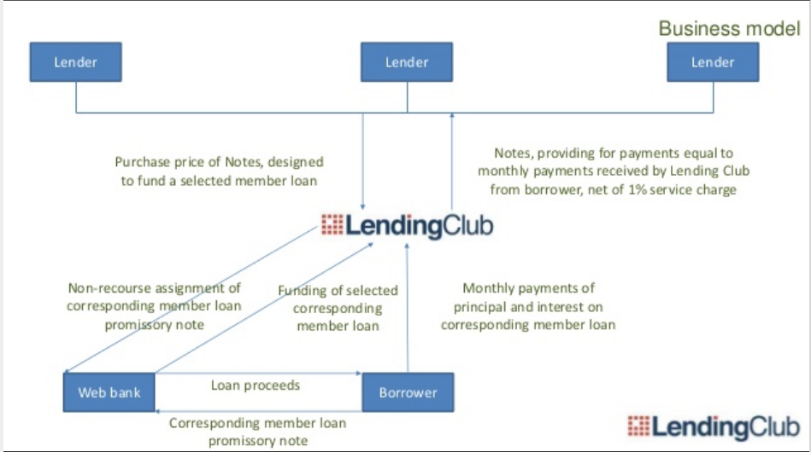

**Lending Club’s Business Model:** The process of an application for a loan to its approval can be explained primarily in three steps:

• Customers interested in a loan complete a simple application at LendingClub.com.

• Lending Club leverages online data and technology to quickly assess risk, determine a credit rating and assign appropriate interest rates. Qualified applicants receive offers and can evaluate loan options with no impact to their credit score.

• Investors ranging from individuals to institutions select loans in which to invest and can earn monthly returns.

**STEP 1:**

***CREATE USER ID AND PASSWORD TO DOWNLOAD LOAN DATA FILES***

Given user name and password by the user, we will be programmatically generating the URL to download the various data file present on the Loan Lending Club Website. We also do have sample file present on their website which does not require any user login but it consist of only sample data with less number of columns.

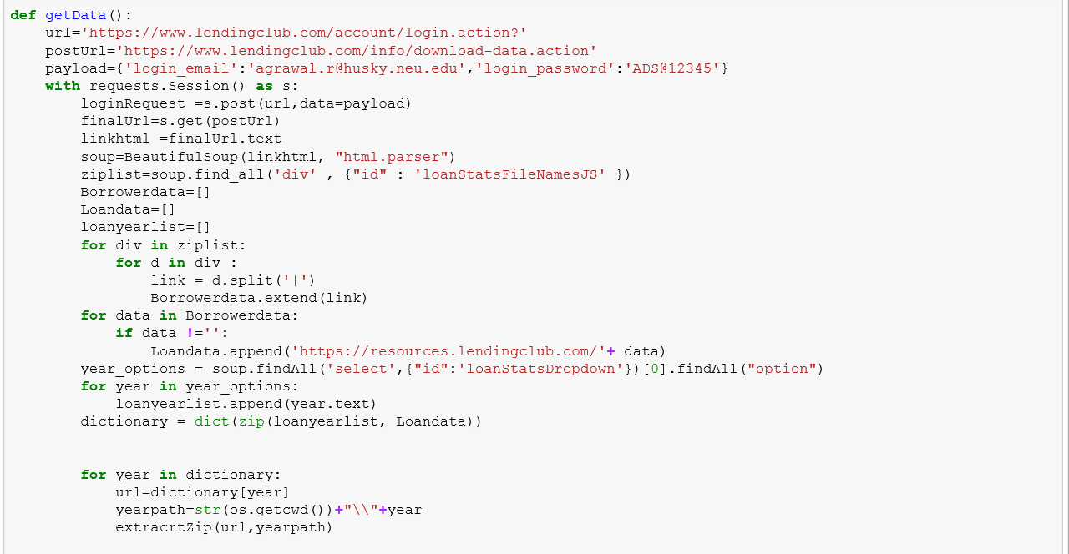

Since we are using python 3.2 for accessing the URL, we should import the following python library to access the Loan Lending club website.

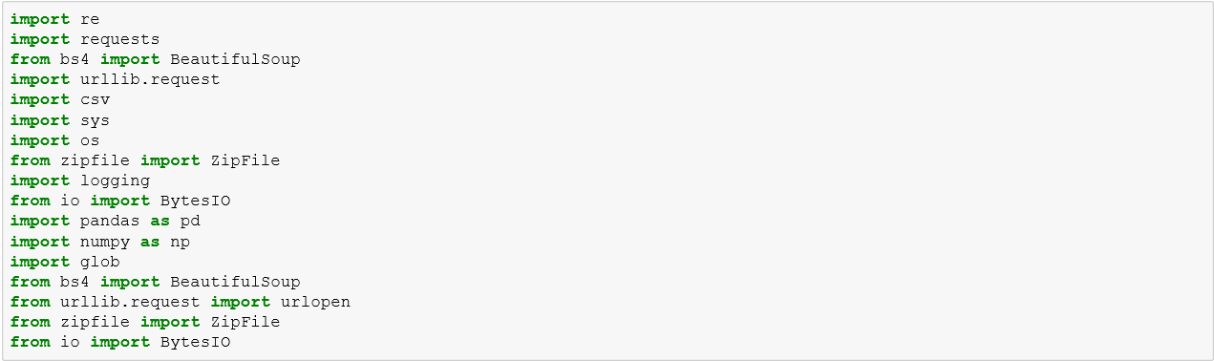

We are storing the user login information in a request session, which allows us to download the actual files present on the Lending Loan club website.

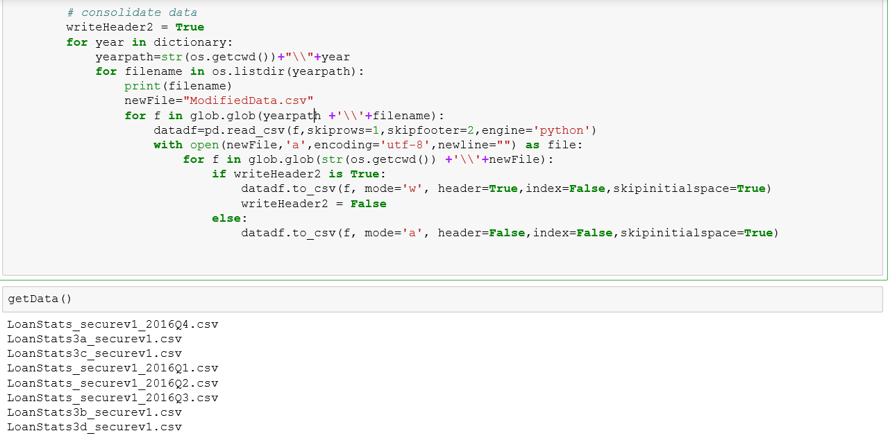

The same method is applied for downloading the file having details of the application which are rejected for granting the loan.

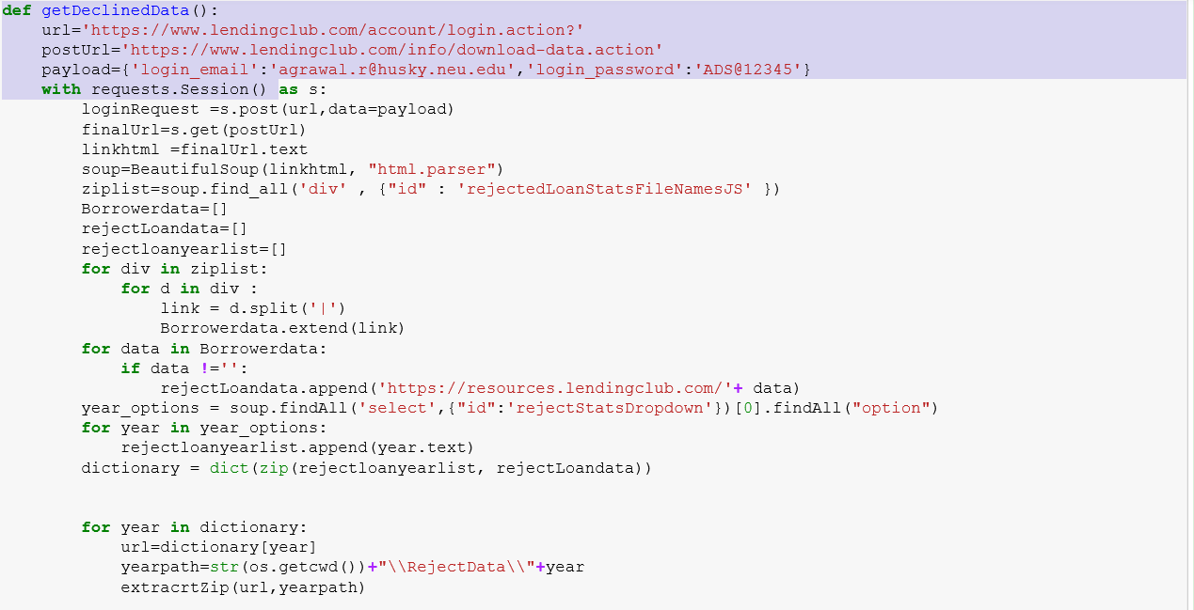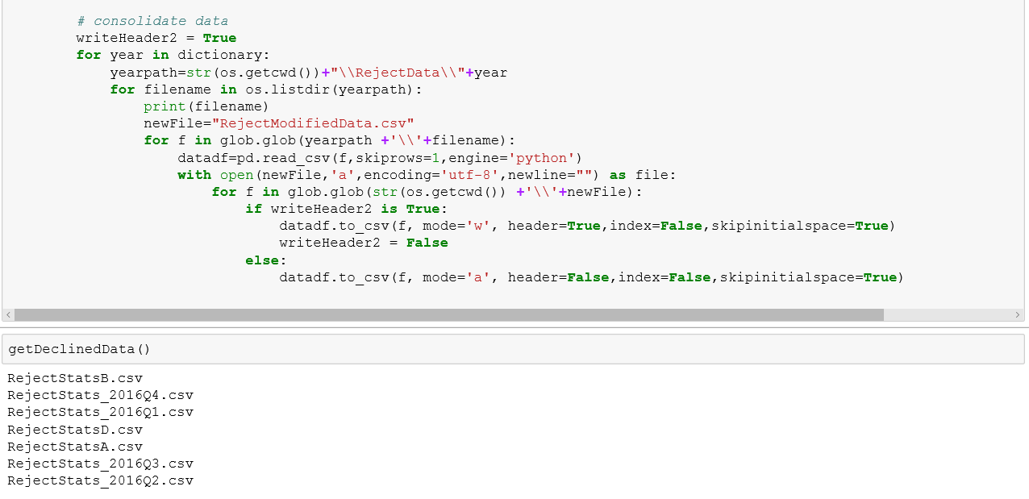

Once we have all the data downloaded as a single csv file, we will load the resultant dataset in pandas data frame for data cleaning and handling missing value.

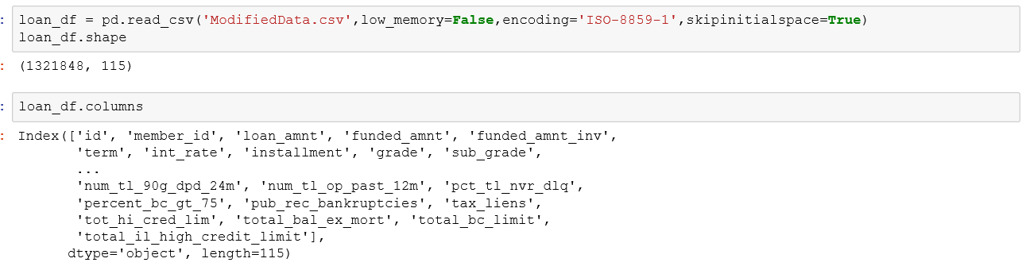

**DATA CLEANING & HANDLING MISSING VALUE**

As shown, resultant loan data frame consists of 1321848 rows with 115 columns.

Same step was performed on the rejected loans application as shown below:

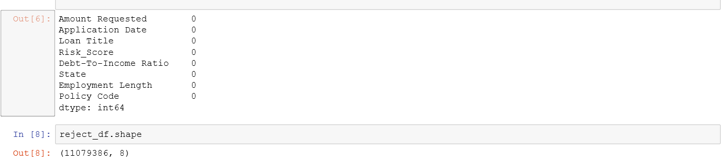

We will now remove all the unused columns which are not useful for the loan data analysis or consist of data which is insignificant. Also, we drop all the column having Null value more than 80% in our data set.

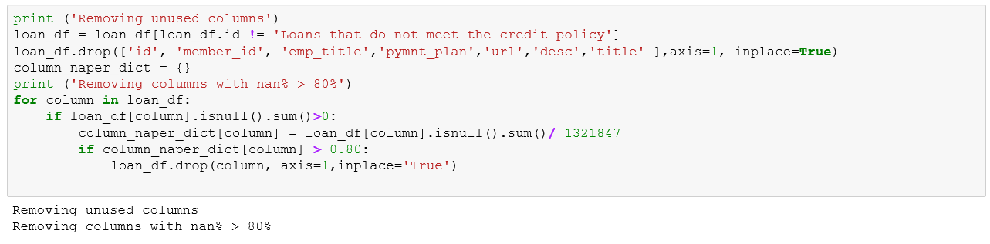

After removing insignificant columns from our dataset, we will work on handling missing data and data cleaning.

Since we have large number of columns in our dataset we will first focus on those columns which are significant in predicting loan interest rate.

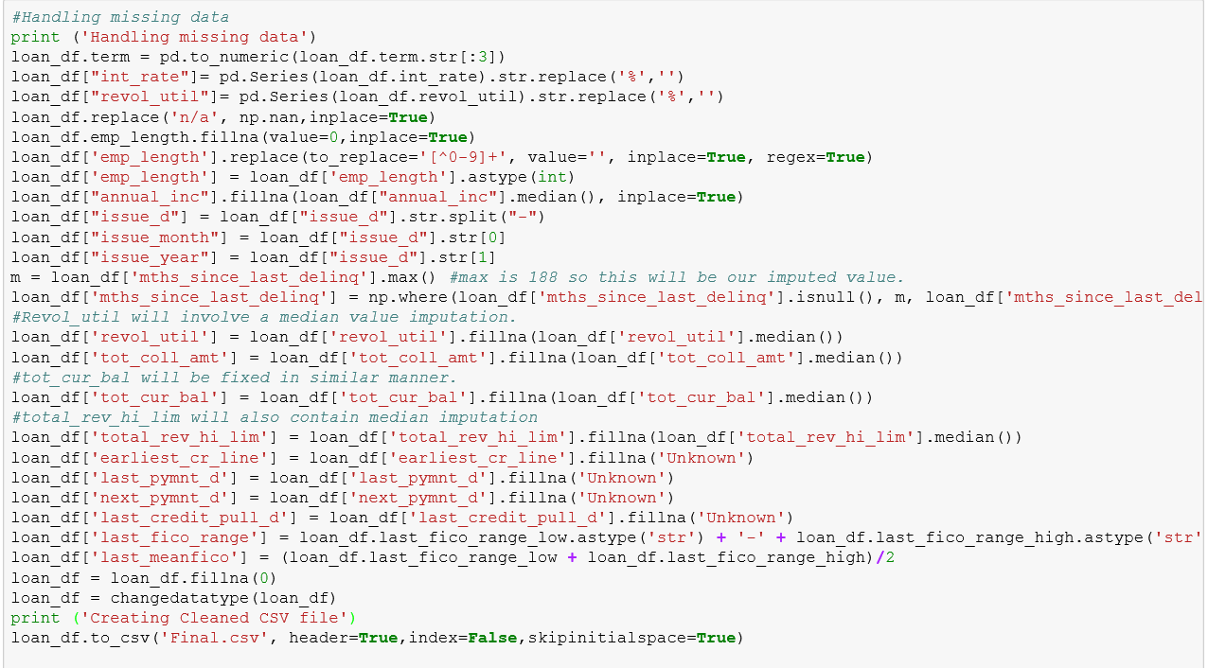

Changing the data types of the columns:

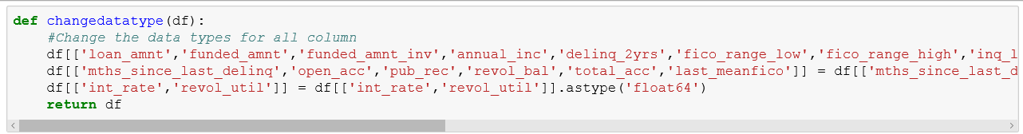

Cleaned Loan Data Set:

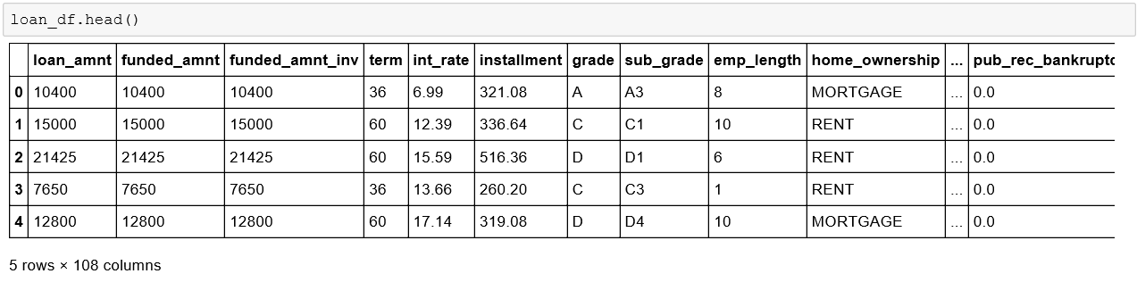

Similarly, all the operation was performed on the Rejected loan data sets:

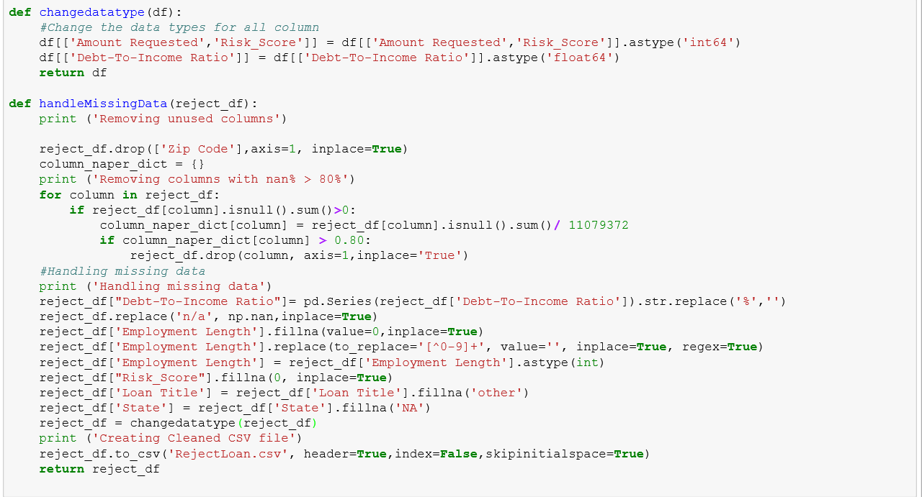

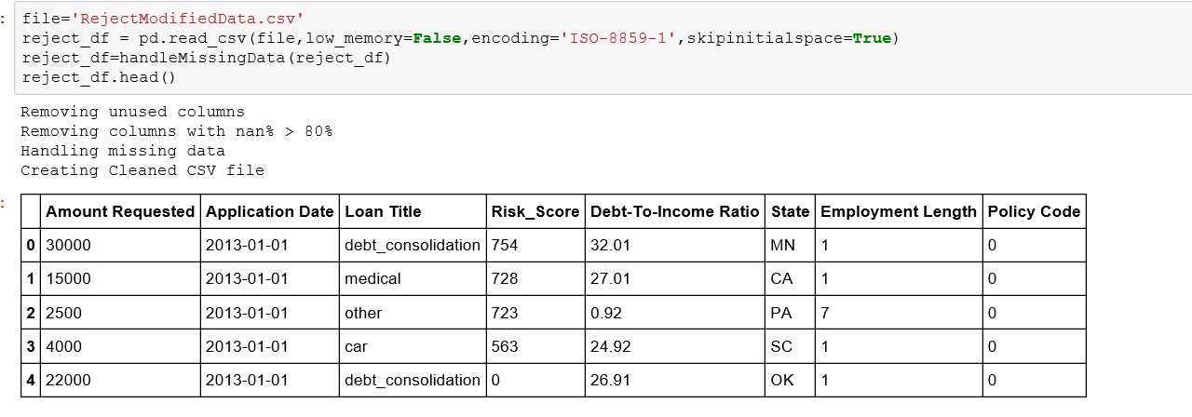

**FEATURE ENGINEERING**

Once we have all the data in the cleaned form, we can use this data for selecting features that significant for predicting the Loan interest rate. Since in the cleaned data set, we still have 108 columns, we need to determine the columns which are provided by the user who is requesting loan from the lending club and the other significant column which are provided by third party to Lending Loan club to determine whether to provide Loan to the applicant or not.

This can be inferred from the data dictionary provided by the Laon Lending club which consist of all the available columns and their definition.



We used standard multivariate linear regression model to associate interest rate with other parameters presented in the data. We selected this model assuming linear relationship of interest rate and FICO range. We also suggested the same kind of relationship between interest rate and some other variables, which we used in our analysis.

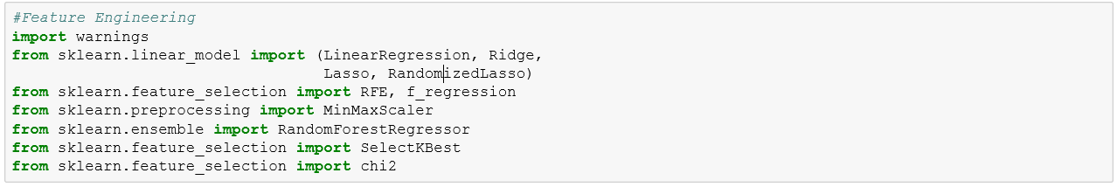

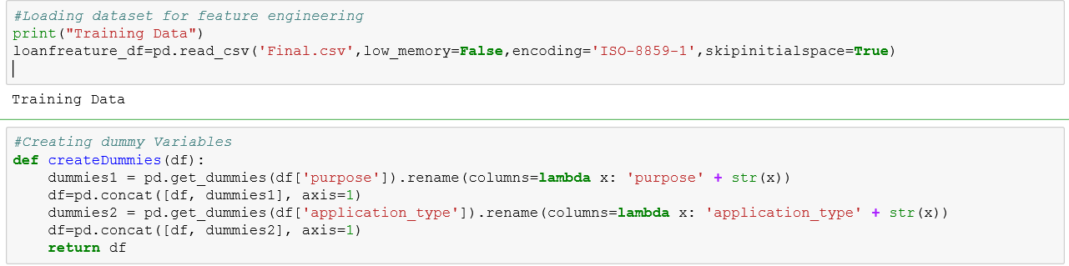

We have changed some of the category columns into numeric.

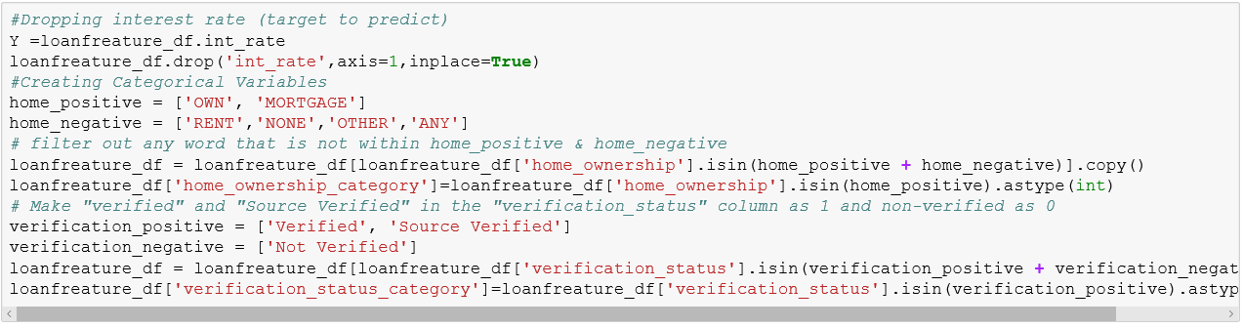

Our analysis suggests that FICO score is not the only parameter predicting Interest Rate and using statistical methods such as multivariate linear regression we show that there is obvious relationship between Interest Rate and the following parameters: Loan length, amount of money funded by investors, debt to income ratio and inquiries in the last 6 months

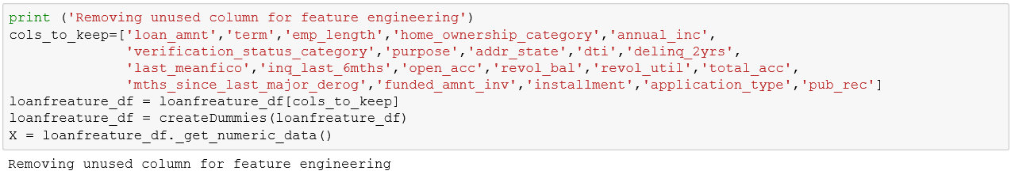 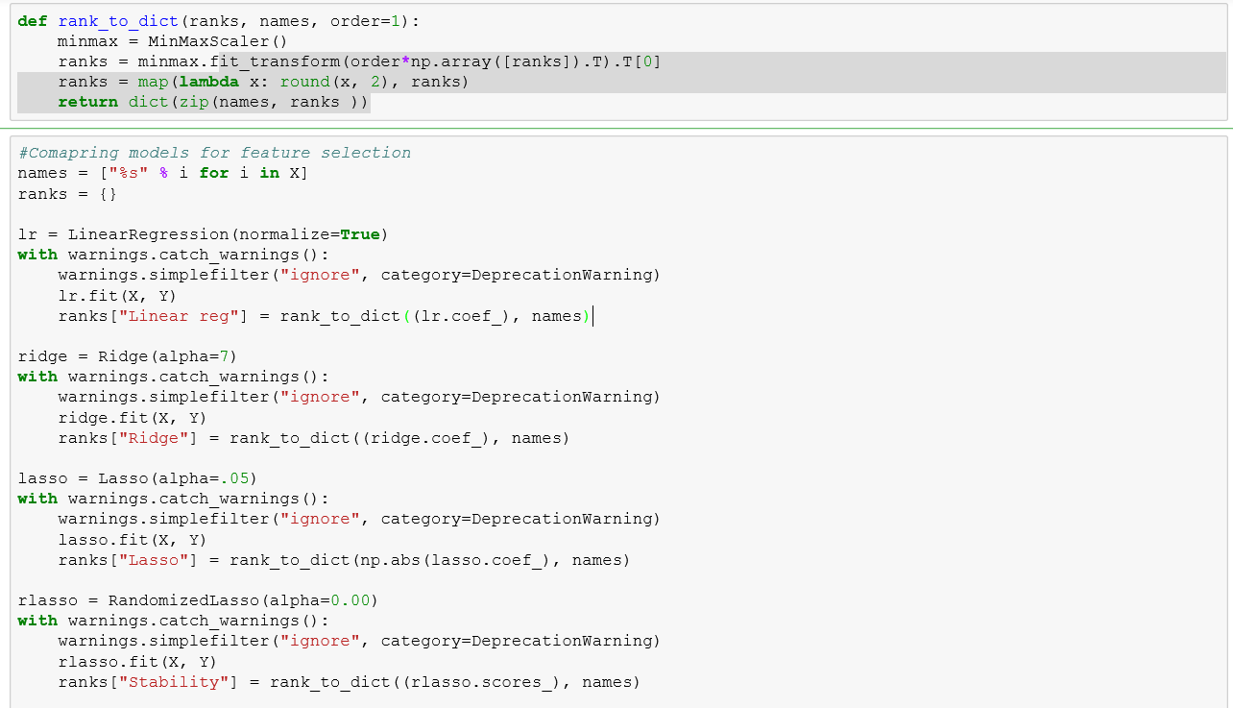 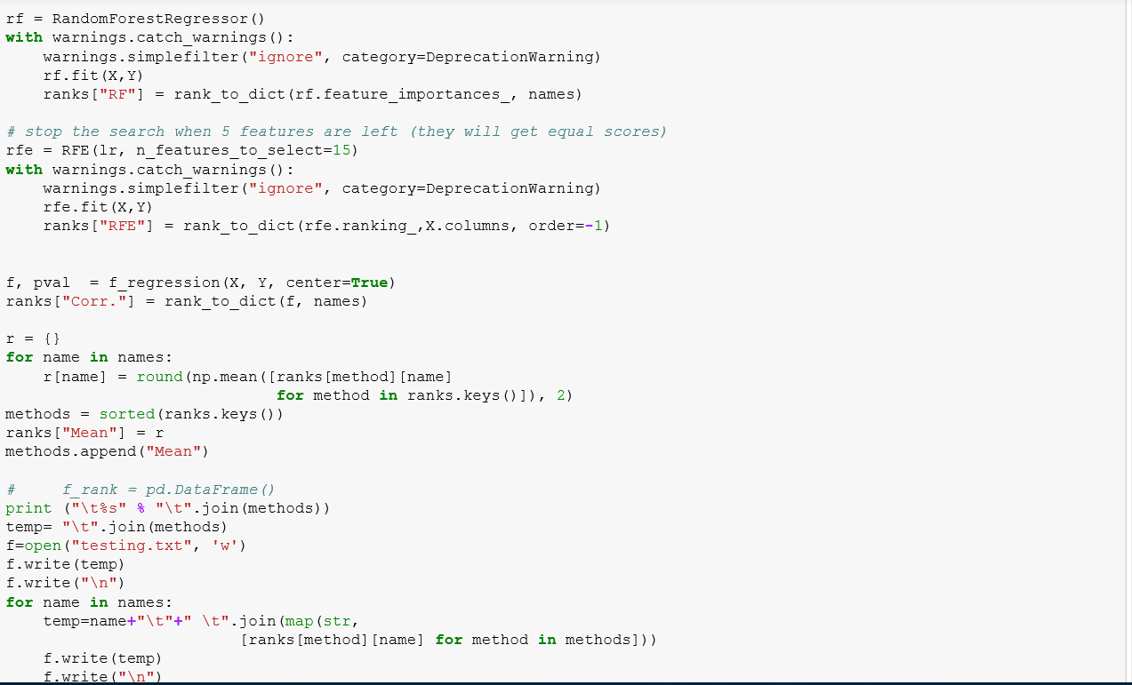**DATA CLEANING & HANDLING MISSING VALUE\**

**Result** :

The analyzed data contains information on the following parameters:

* Amount of requested money in dollars (Amount.Requested)
* Amount of money that was loaned to the individual(Amount.Funded.By.Investors)
* Length of time of the loan in months (Loan.Length)
* Purpose of a loan as stated by the applicant (Loan.Purpose)
* The percentage of customer gross income that goes toward paying debt (Debt.To.Income.Ratio)
* The abbreviation for the U.S. state of residence of (State)
* A variable indicationg whether the applicant owns, rents or has a mortgage on his home (Home.ownership)
* The monthly income of the applicant in dollars (Monthly.income)
* A measure of the creditworthiness of the applicant, FICO Score (FICO.Range)
* The number of open lines of credit the applicant had at the
* time of application (Open.CREDIT.Lines)
* The total amount outstanding all lines of credit (Revolving.CREDIT.Balance)
* The number of authorized queries about the applicant's creditworthness in the 6 months before the credit was issued (Inquiries.in.the.Last.6.Months)
* Length of time employed at current job (Employment.Length)



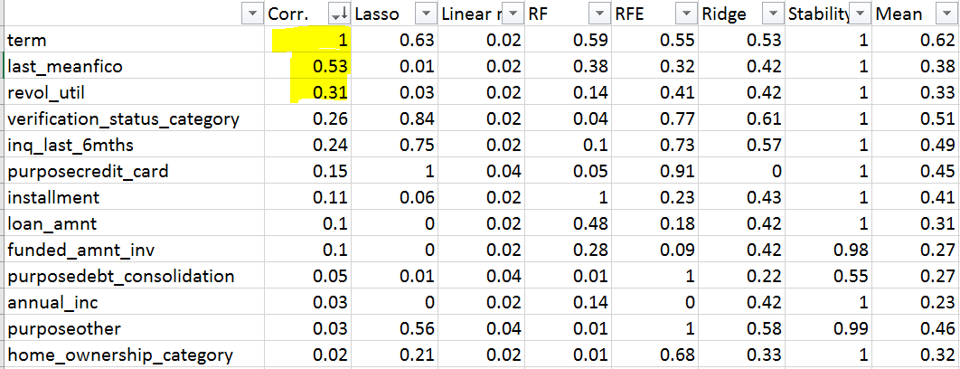

Correlation analysis showed high negative correlation between Interest rate and FICO score and moderate positive correlation between interest rate and loan length and amount of money funded by investors.

There also is slight positive correlation between interest rate and inquires in the last six months and quantity of open credit lines.

**Rejected Loan Data Files:**

As we don’t have target variable to predict, we choose to see the correlation between the variable.

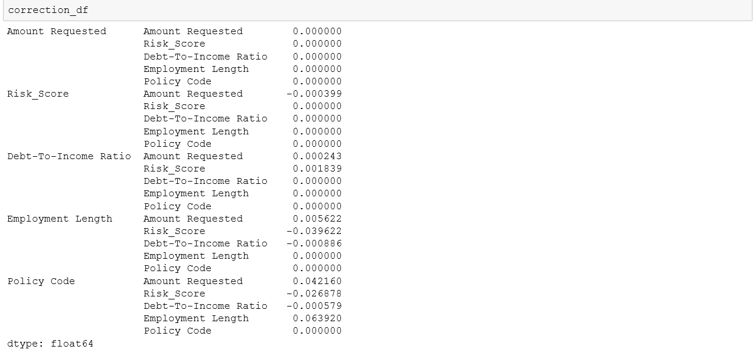

Also, these were the entries which were provided by the requester while requesting a loan from Lending Loan club.

* **Amount Requested**
* **Fico_Score**
* **Annual Income**
* **Employment Length**

**SECTION – 3 PIPELINING PROCESS USING LUIGI**

Luigi is a Python-based framework for expressing data pipelines. Everything in Luigi is in Python.

Luigi performs following functions in a pipeline for Loan data which is approved:

1. getWebUrls-Fetching urls for file download

2. getData-Merging the data from all downloaded file into a single file

3. handleMissingData-Managed missing data in the file

4. processData-Intermediate step for featureselection

5. featureSelection –Selects relevant features by applying several feature selection techniqiues.

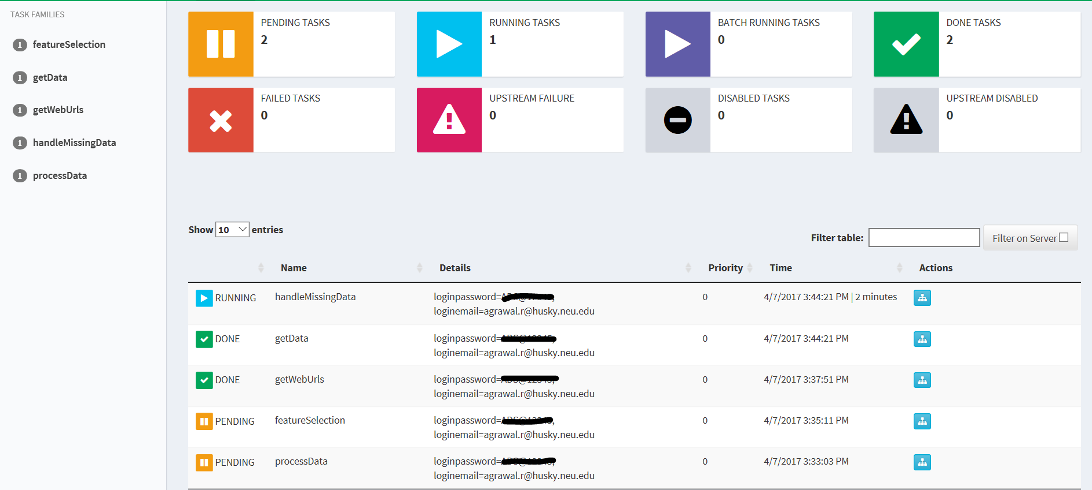

Pipeline is completed when all the tasks into it are completed i.e. green status.

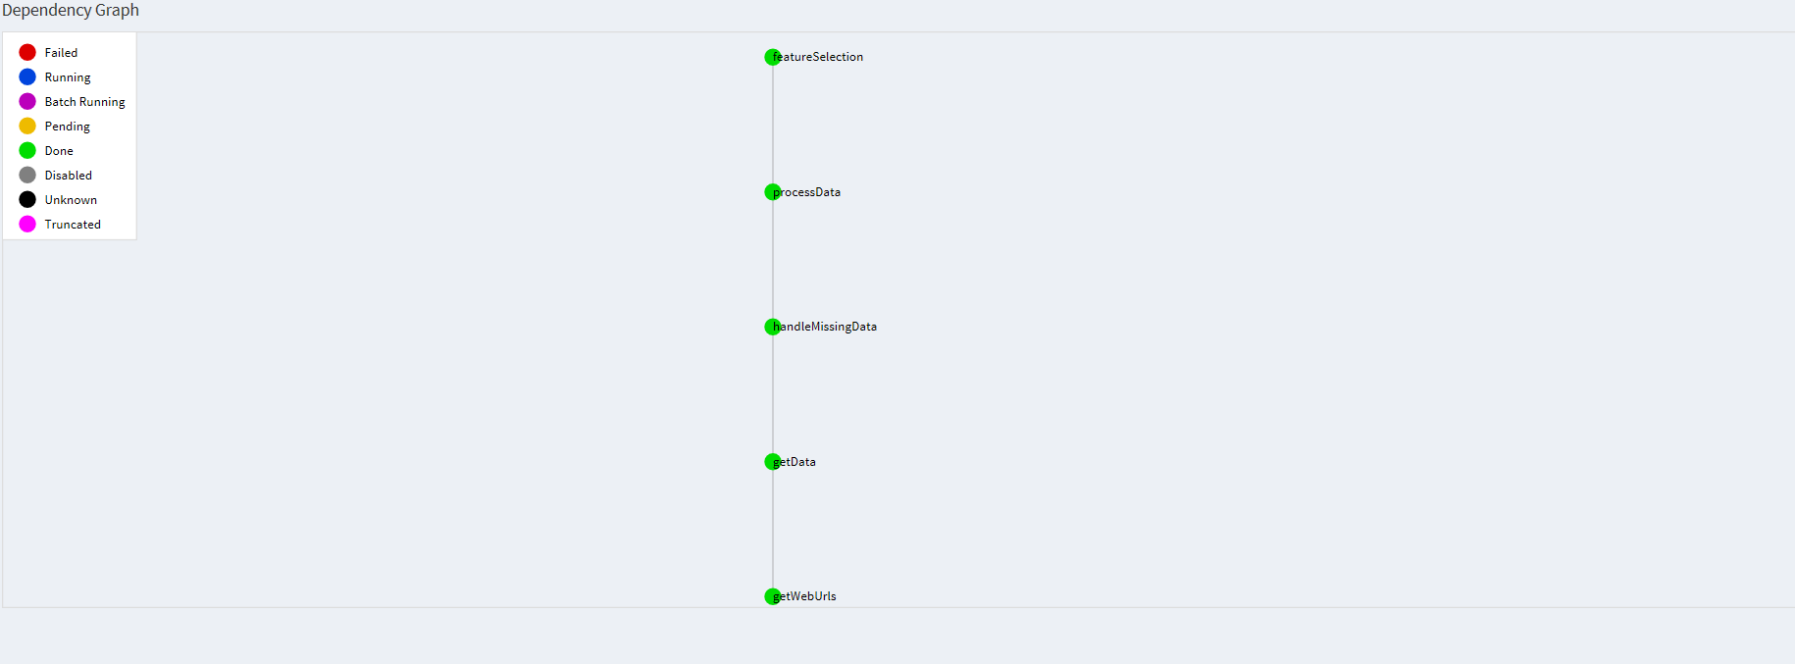

Time taken by each task can be seen as follows:

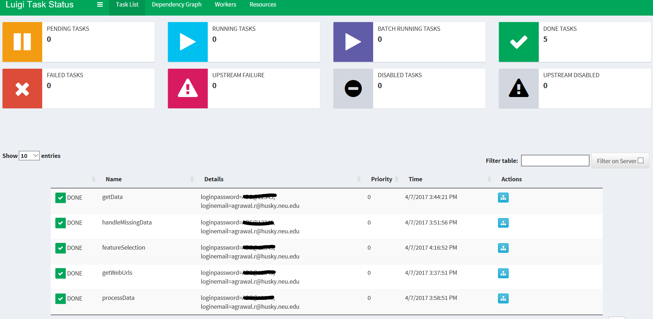

Similarly, we implemented Luigi pipeline for rejected data:

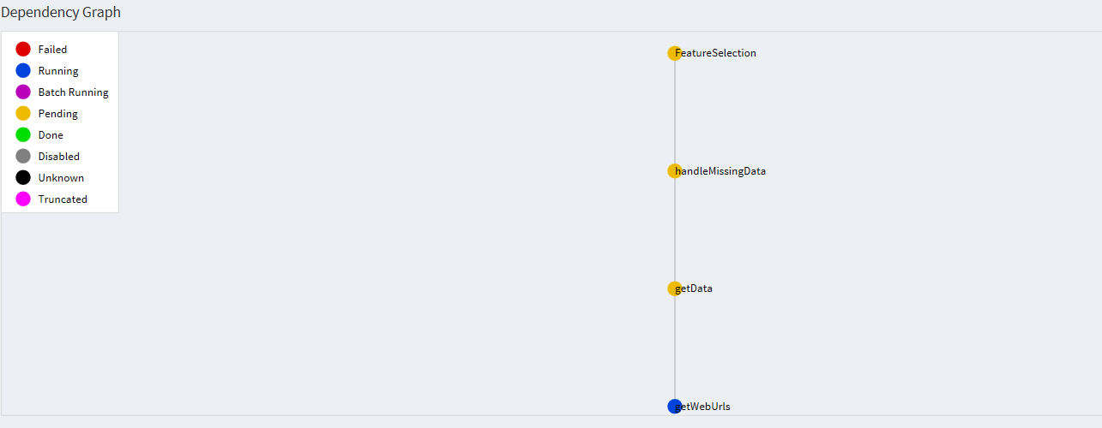

**SECTION - 2 DOCKERIZE PART 1**

**DOCKERIZE PART 1**

**STEP 1:**

**CREATE THE DOCKER IMAGE FROM DOCKERFILE**

* 1. After taking the base UBUNTU 14.04 image.

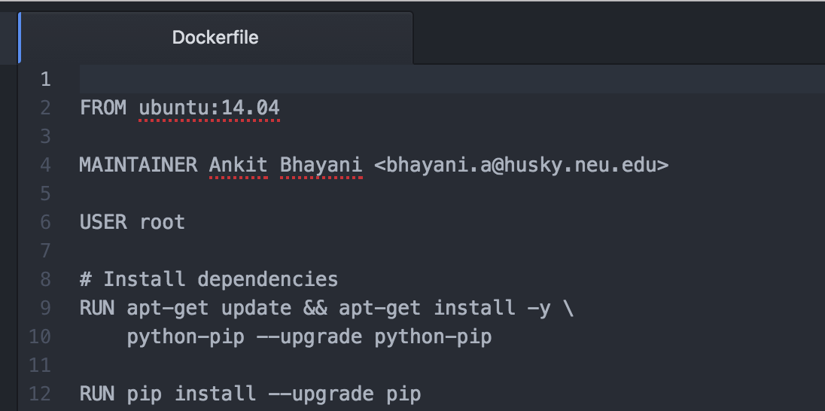

* 1. Install Python and all required packages which is used in source code

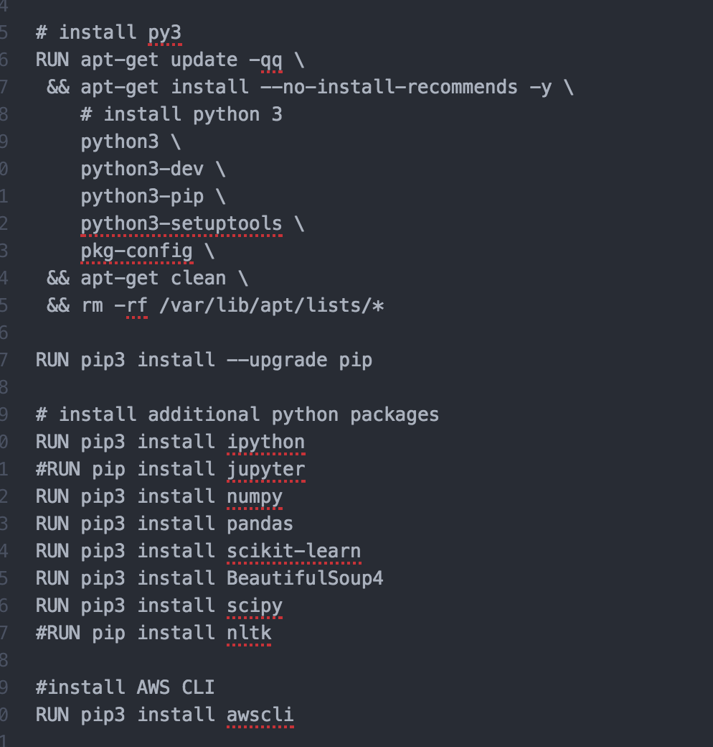

* 1. While building Docker File; First creating the work directory and then copying the source python and shell files from local machine to DOCKER image.

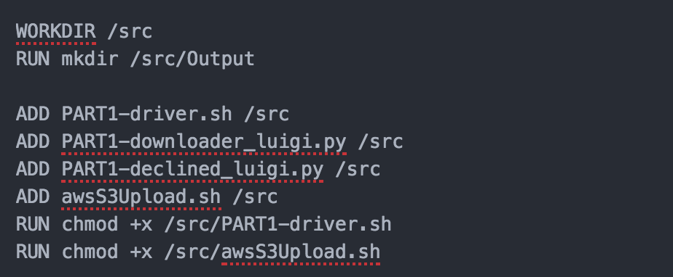

**STEP 2:**

**BUILD THE DOCKERFILE TO CREATE THE DOCKER IMAGE**

Building this Docker file will create a DOCKER image with name ankitbhayani/FirstAssignmentImage



Each step in this file will be executed in order to create an image. AWS CLI is also integrated inside the dockerfile

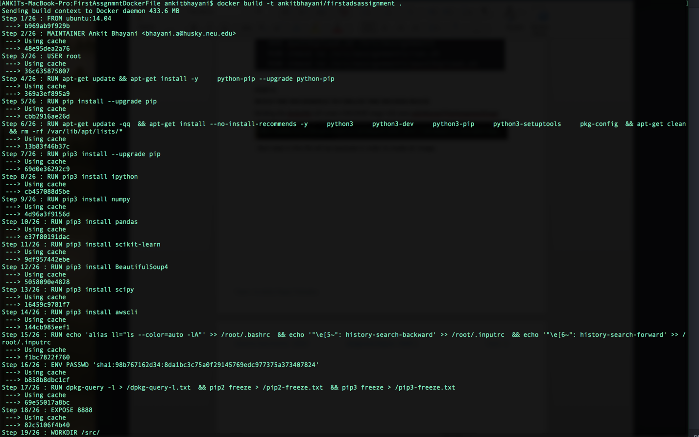

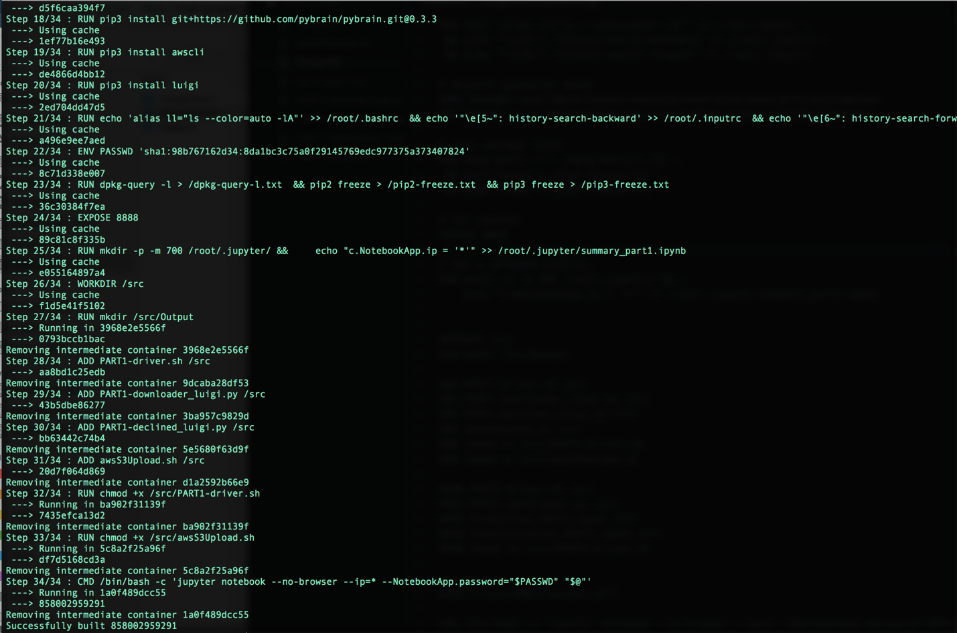

**STEP 3:**

**PUSH THIS DOCKER IMAGE to DOCKERHUB**

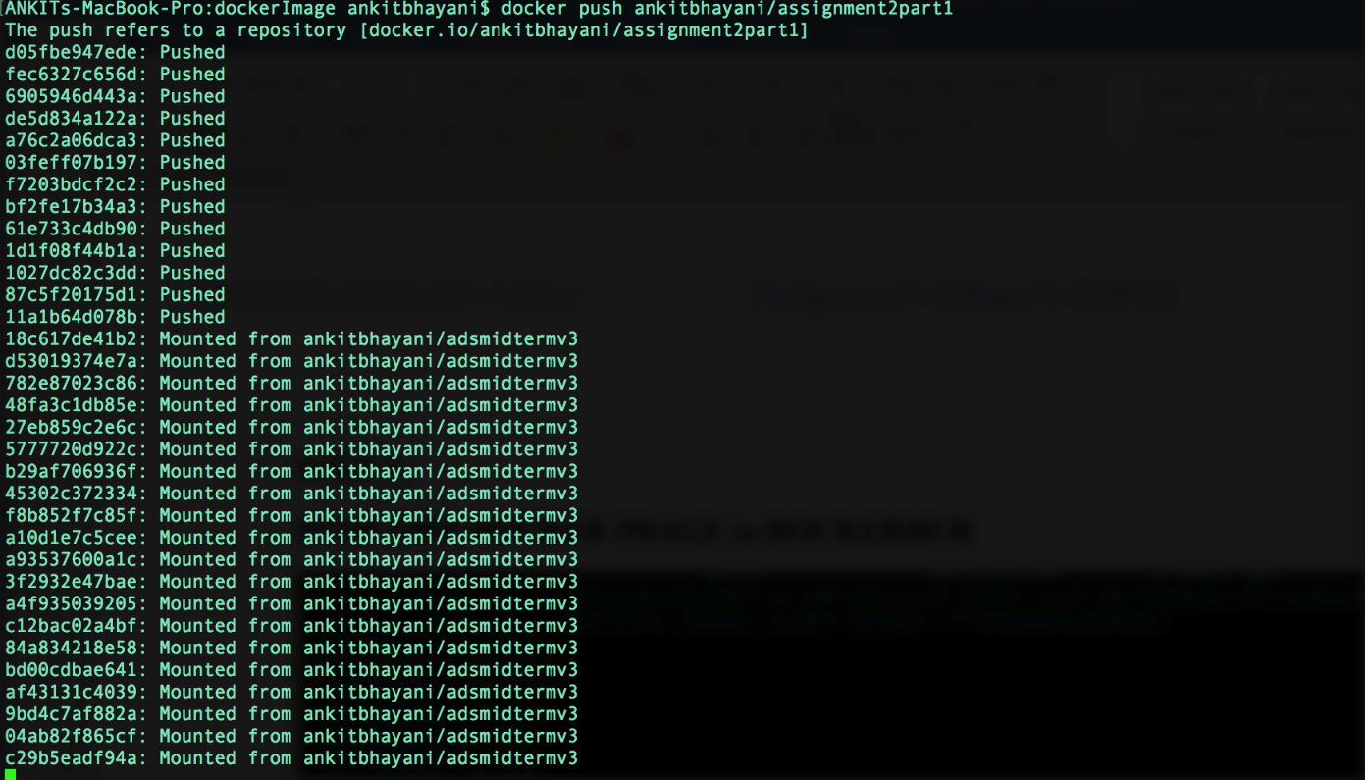

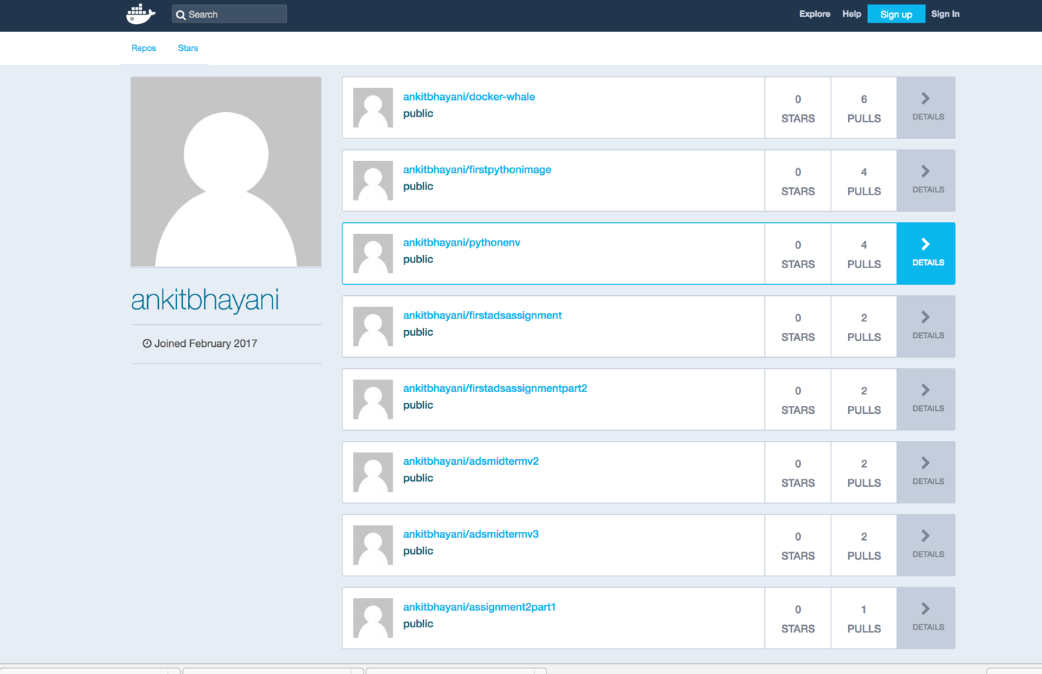

**STEP 4:**

**DOCKER RUN INSTRUCTIONS:**

**Pull an image from dockerhub:**

docker pull ankitbhayani/assignment2part1

**Run the docker image (for Lending-Club full data):**

docker run -e ACCESS_KEY=**<YOUR_ACCESS_KEY>**

-e SECRET_KEY=**<YOUR_SECRET_KEY>**

-e S3_PATH=**<YOUR_S3_PATH>**

-e REGION=**<BUCKET_REGION>**

-e USERNAME=**<LENDINGCLUB_USERNAME>**

-e PASSWD=**< LENDINGCLUB_PASSWD >**

ankitbhayani/assignment2part1

/src/PART1-driver.sh

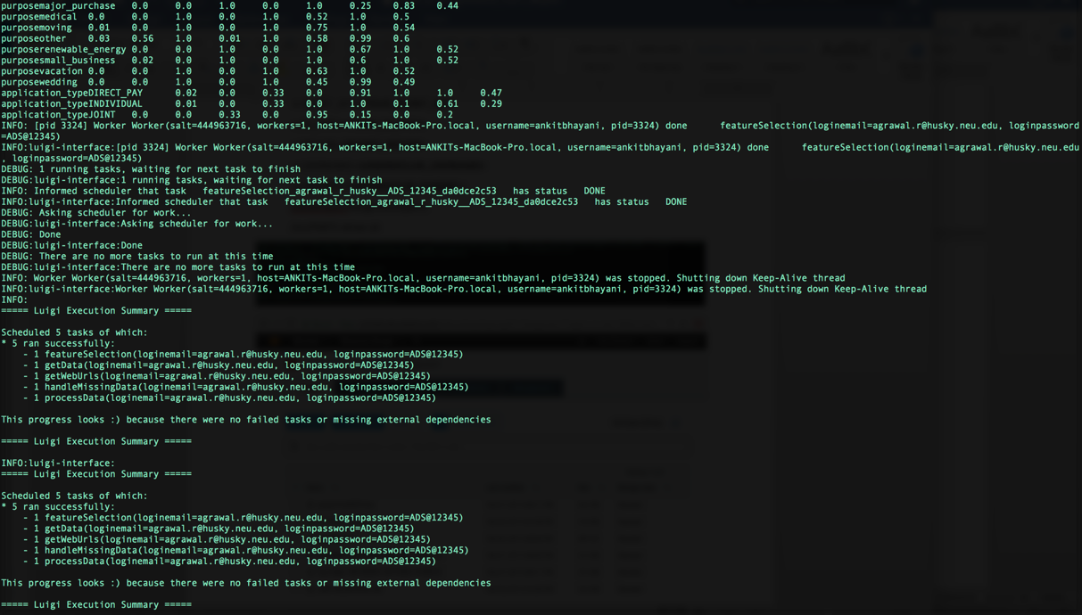

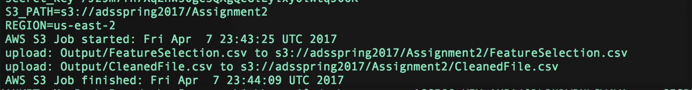

**Run the docker image (for Lending-Club Declined data):**

docker run -e ACCESS_KEY=**<YOUR_ACCESS_KEY>**

-e SECRET_KEY=**<YOUR_SECRET_KEY>**

-e S3_PATH=**<YOUR_S3_PATH>**

-e REGION=**<BUCKET_REGION>**

-e USERNAME=**<LENDINGCLUB_USERNAME>**

-e PASSWD=**< LENDINGCLUB_PASSWD >**

ankitbhayani/assignment2part1

/src/PART1-driver.sh declined

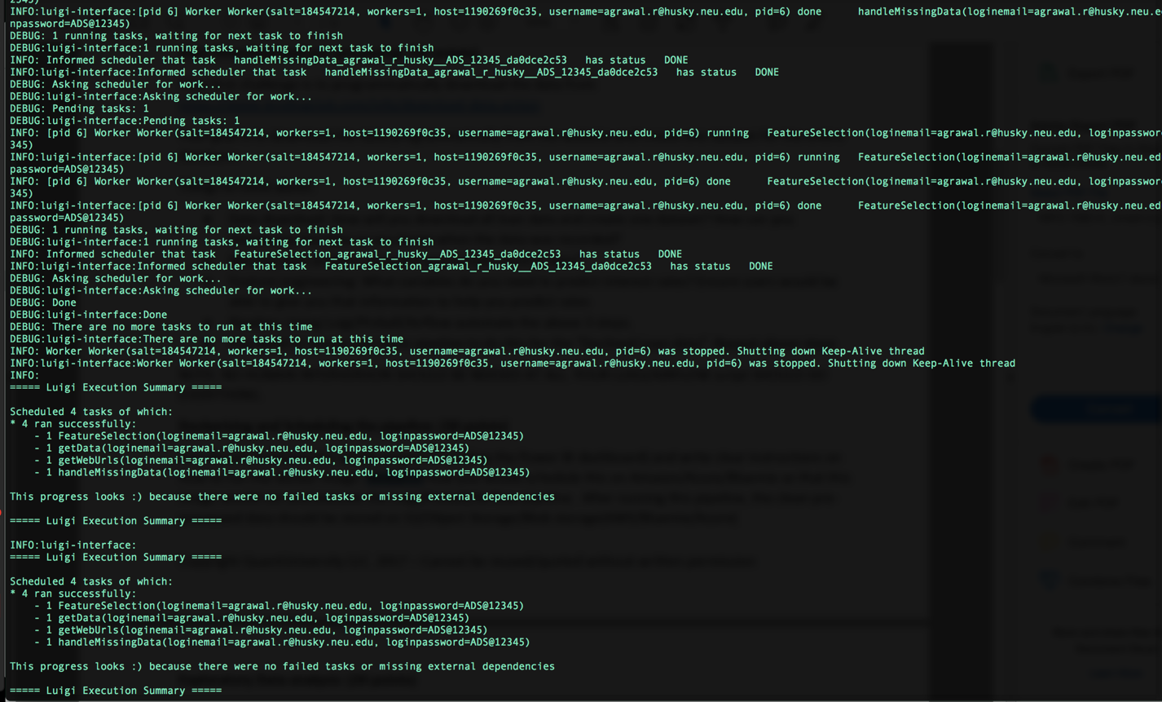

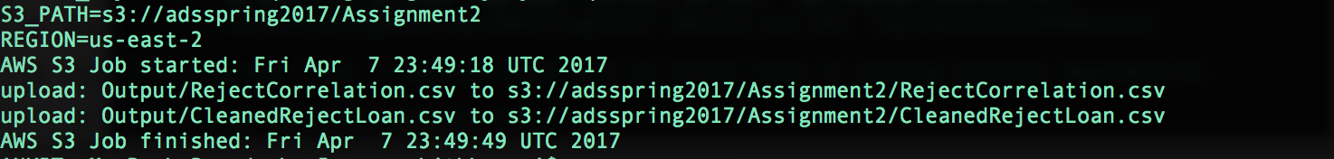

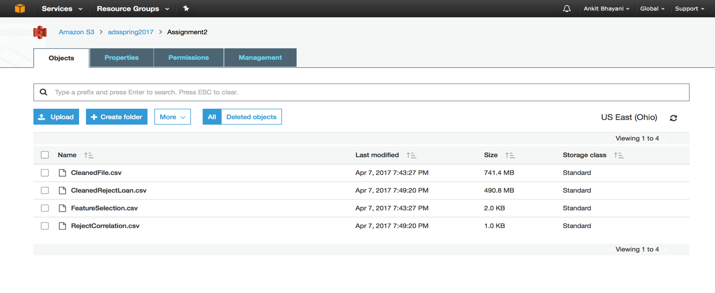

**DRIVER CODE HANDLING THROUGH SHELL FILE:**

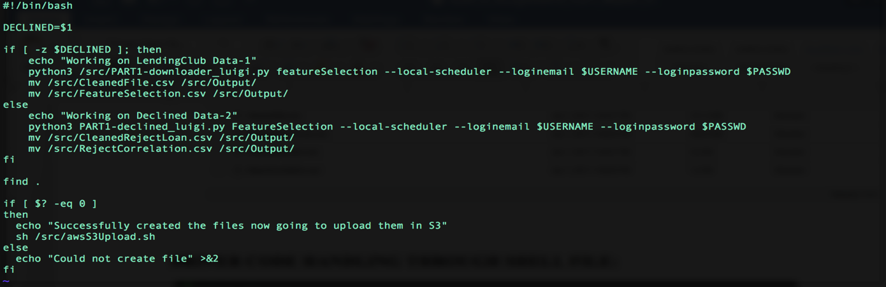

**AWS S3 UPLOAD SHELL FILE:**

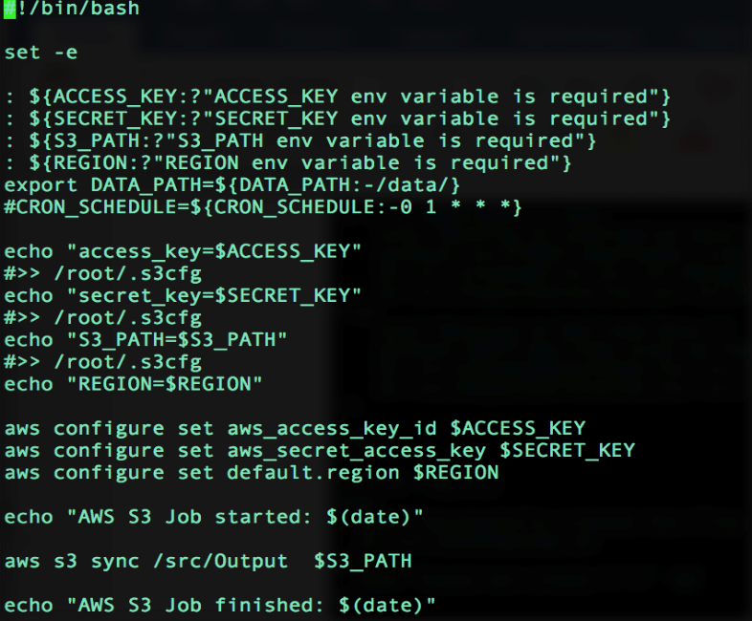

**RESEARCH ON SCHEDULING THE PIPELINE**

Architecture:

When we need to execute a long-running or periodic jobs in AWS, it’s been very conventional to write our scripts and configure them as **cron job** on EC2 instances. However, we risk the failure of EC2 instances and we may also have problem in its scalability.

Amazon EC2 Container Service (ECS) is a highly scalable, high performance container management service that supports Docker containers and allows us to easily run applications on a managed cluster of Amazon EC2 instances. Amazon ECS eliminates the need for us to install, operate, and scale our own cluster management infrastructure. With simple API calls, we can launch and stop container-enabled applications, query the complete state of our cluster, and access many familiar features like security groups, Elastic Load Balancing, EBS volumes and IAM roles.

 Triggers  Invokes  Stores data in 

CloudWatch Lambda Function EC2 Container Service - ECS Amazon S3

In AWS **CloudWatch Events**, configure the schedule CRON expression as **0 12 * * ? \*** and configure the constant JSON input payload like:

{  
 “ecs_task_def”: “my_task_def”,  
 “region”: “us-west-2”,  
 “cluster”: “default”,  
 “count”: 1  
 }

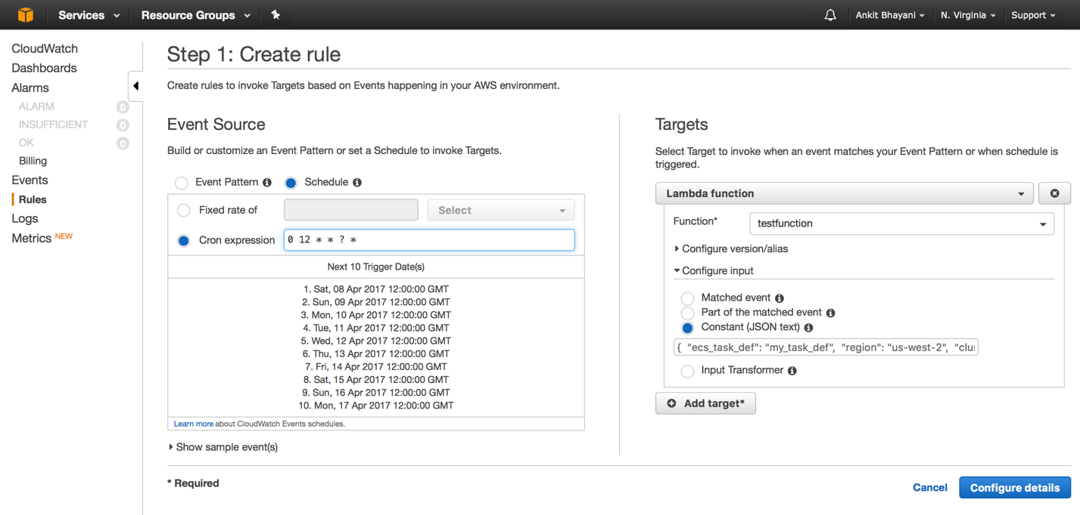

It will trigger an event at every day at 12:00PM. When invoking Lambda function, the input payload above will construct itself as the ***event*** object for Lambda, and Lambda will hence perform the one-shot task running on ECS as we expect. Following are some more examples of scheduling through cloudwatch events:

|  |  |  |  |  |  |  |
| --- | --- | --- | --- | --- | --- | --- |
| **Minutes** | **Hours** | **Day of month** | **Month** | **Day of week** | **Year** | **Meaning** |
| 0 | 10 | * | * | ? | * | Run at 10:00 am (UTC) every day |
| 15 | 12 | * | * | ? | * | Run at 12:15 pm (UTC) every day |
| 0 | 18 | ? | * | MON-FRI | * | Run at 6:00 pm (UTC) every Monday through Friday |
| 0 | 8 | 1 | * | ? | * | Run at 8:00 am (UTC) every 1st day of the month |
| 0/15 | * | * | * | ? | * | Run every 15 minutes |
| 0/10 | * | ? | * | MON-FRI | * | Run every 10 minutes Monday through Friday |
| 0/5 | 8-17 | ? | * | MON-FRI | * | Run every 5 minutes Monday through Friday between 8:00 am and 5:55 pm (UTC) |

**AWS Lambda** let us run the code without provisioning or managing servers (*server-less* fashion). We pay only for the compute time we consume - there is no charge when our code is not running. With Lambda, we can run code for virtually any type of application or backend service - all with zero administration. We just need to upload our code and Lambda takes care of everything required to run and scale our code with high availability. We can also set up our code to automatically trigger from other AWS services or call it directly from any web or mobile app.

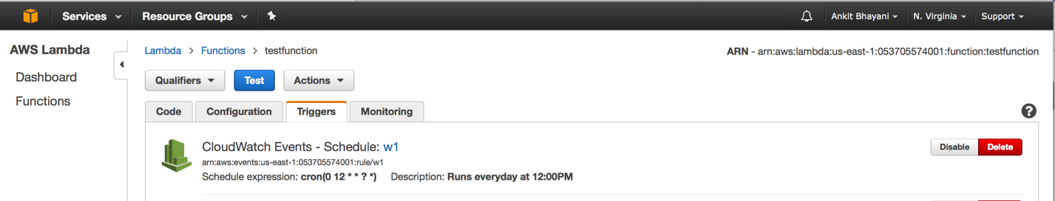

*Code(ecs-task-runner):*

|  |  |
| --- | --- |
|  | var AWS = require('aws-sdk') |
|  | var ecs = new AWS.ECS(); |
|  | exports.handler = (events, context) => { |
|  | // CLI example: |
|  | // aws --region ap-northeast-1 ecs run-task --task-definition my_task_def |
|  | /* input event payload sample: |
|  | { |
|  | "ecs_task_def": "my_task_def", |
|  | "region": "us-west-2", |
|  | "cluster": "default", |
|  | "count": 1 |
|  | } |
|  | */ |
|  |  |
|  | console.log(events) |
|  | var ecs_task_def = events.ecs_task_def || 'undefined' |
|  | var exec_region = events.region || 'ap-northeast-1' |
|  | var cluster = events.cluster || 'default' |
|  | var count = events.count || 1 |
|  | console.log(ecs_task_def, exec_region) |
|  | var params = { |
|  | taskDefinition: ecs_task_def, |
|  | cluster: cluster, |
|  | count: count |
|  | } |
|  | ecs.runTask(params, function(err, data) { |
|  | if (err) console.log(err, err.stack); // an error occurred |
|  | else console.log(data); // successful response |
|  | context.done(err, data) |
|  | }) |
|  |  |
|  | } |

An interesting approach is to wrap our business logic of periodic long-running jobs into Docker images and compile them into **AWS ECS Task Definitions** and use the **ECS CLI** or **SDK** to *run-task* with them. The ECS scheduler will try to allocate resources for the task on proper ECS instance and execute the Docker command we wrapped in.

**ECS CLI**

Since we already wrap our codes of business logic into the docker image and created our ECS task definition. It’s very easy to run the task for one-shot just like this:

aws --region ap-northeast-1 ecs run-task --task-definition my_task_definition

**ECS Console -** *Docker Repository on ECS*

Register your docker image with ECS with following commands:

1. Retrieve the docker login command that you can use to authenticate your Docker client to your registry:

aws ecr get-login --region us-east-1

1. Run the docker login command that was returned in the previous step.
2. Build your Docker image using the following command. For information on building a Docker file from scratch see the instructions [here](http://docs.aws.amazon.com/AmazonECS/latest/developerguide/docker-basics.html). You can skip this step if your image is already built:

docker build -t dockerrepository .

1. After the build completes, tag your image so you can push the image to this repository:

docker tag dockerrepository:latest 053705574001.dkr.ecr.us-east-1.amazonaws.com/dockerrepository:latest

1. Run the following command to push this image to your newly created AWS repository:

docker push 053705574001.dkr.ecr.us-east-1.amazonaws.com/dockerrepository:latest

**Repository Sceenshot which contains latest image pushed from the terminal.**

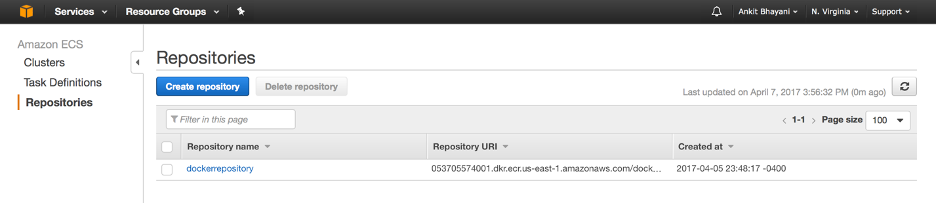

**Creating the task which will be executed on ec2 container.**

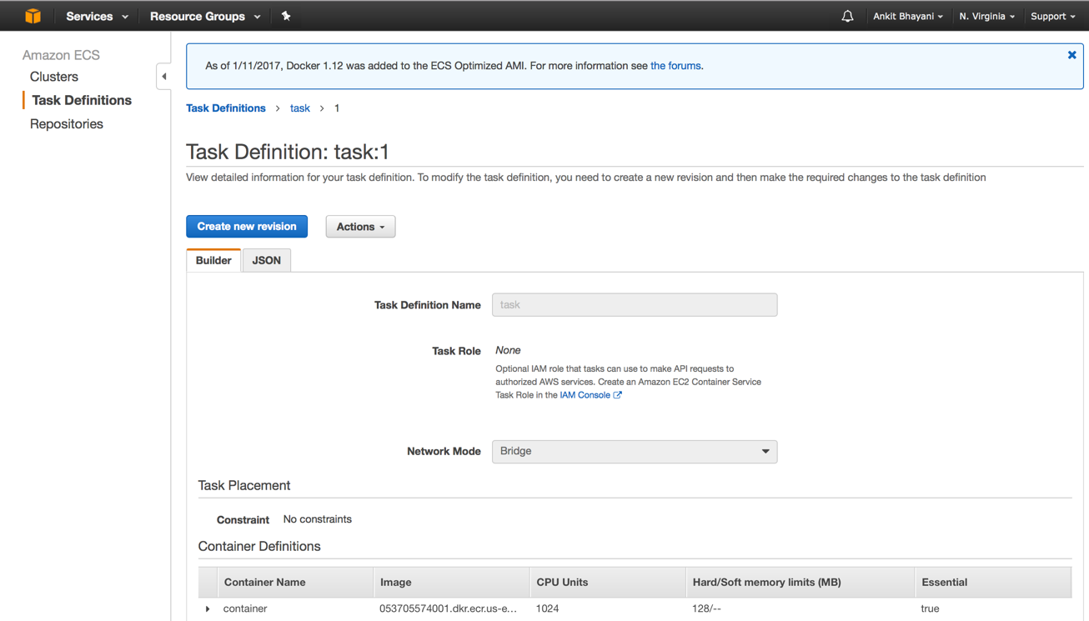

**Creating a cluster which will provide the infrastructure to run above task and service**

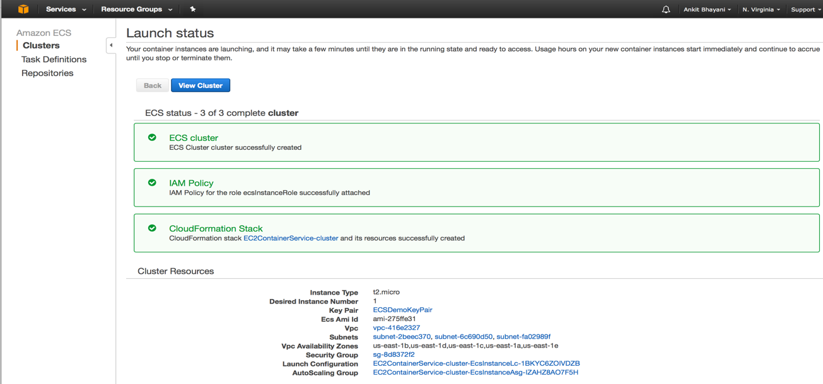

**Create service**

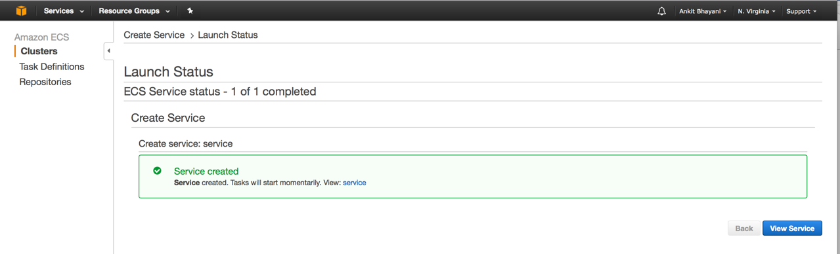

**Cluster started with**

* **1 service, 1 Running task and 1 container instance**
* **0% CPU and memory utilization at this time**

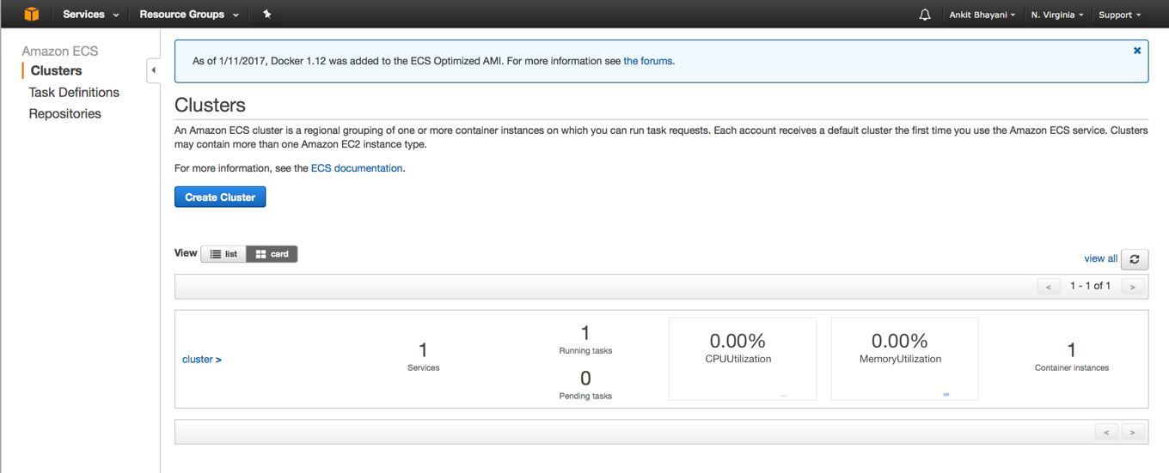

**ECS instance invoked**

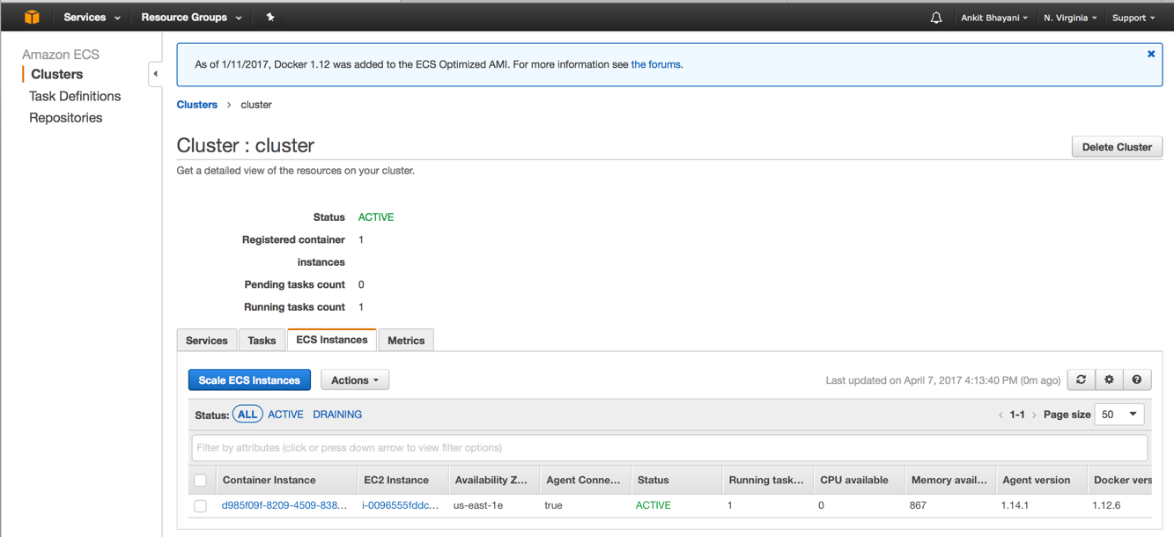

**Cluster Metrics for CPU and memory utilization after a while**

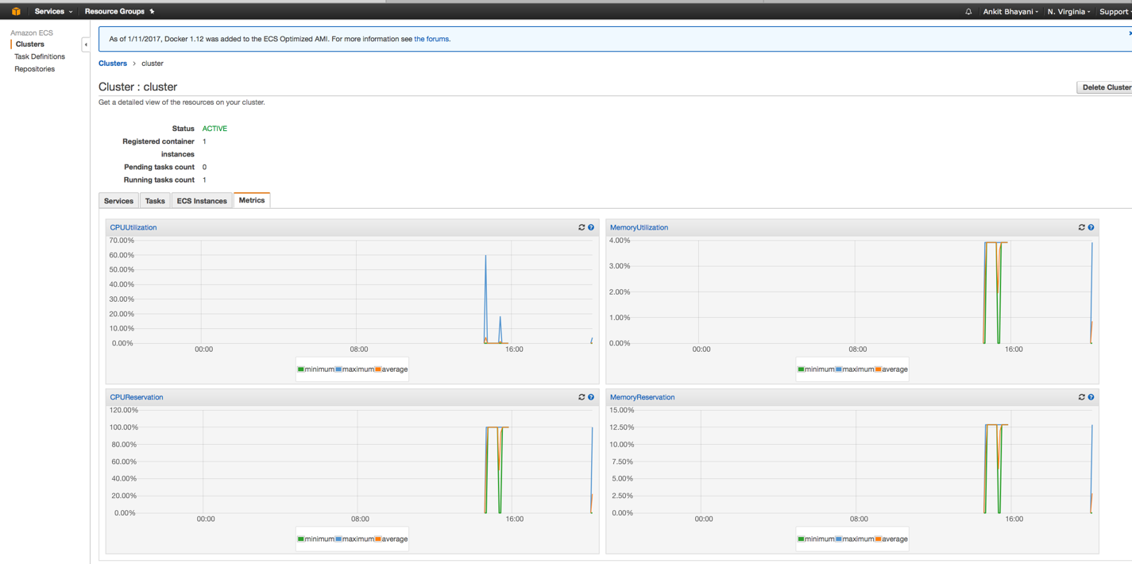

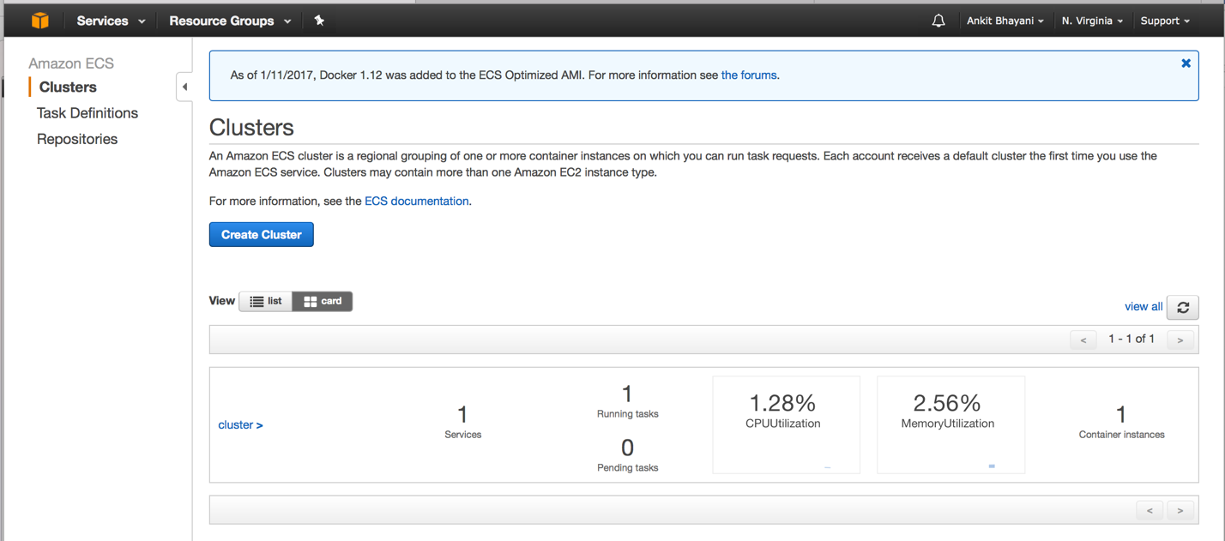

**ANALYSIS THROUGH POWER BI**

**STATEWISE Comparison**

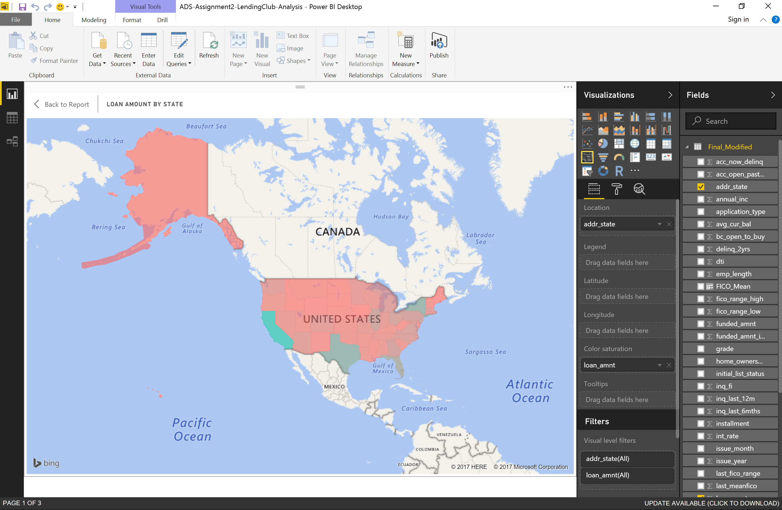

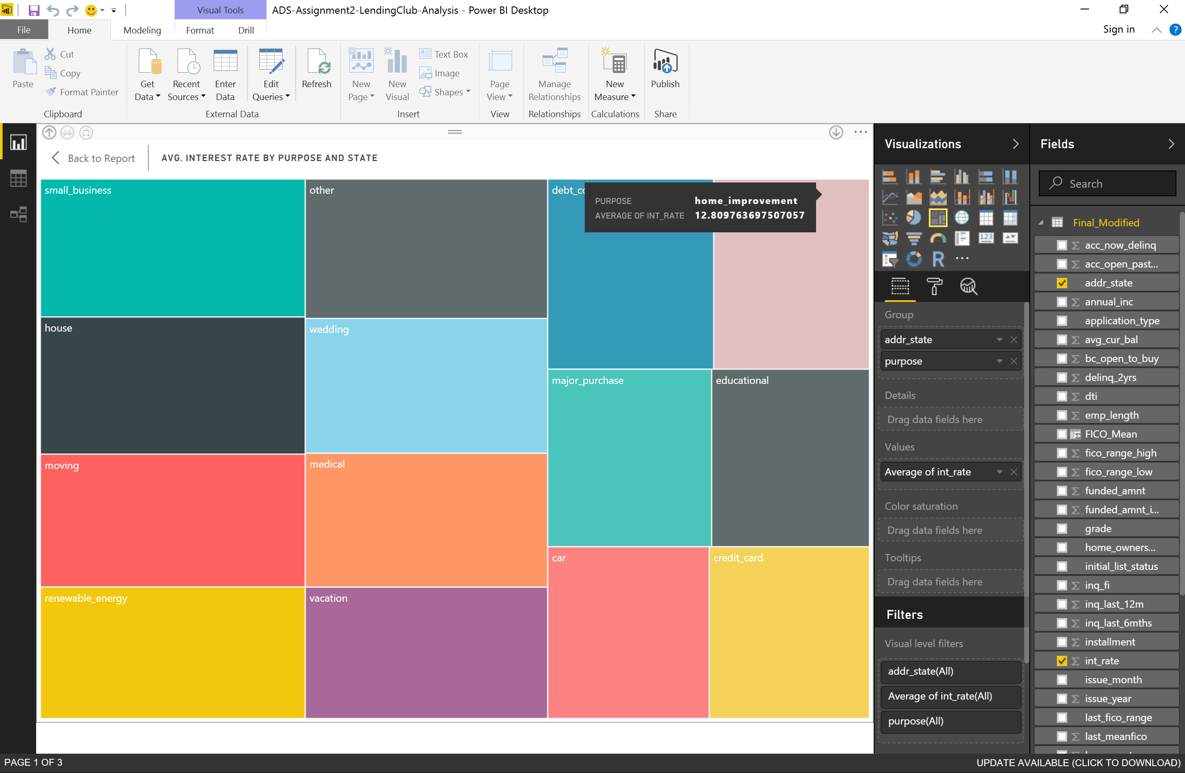

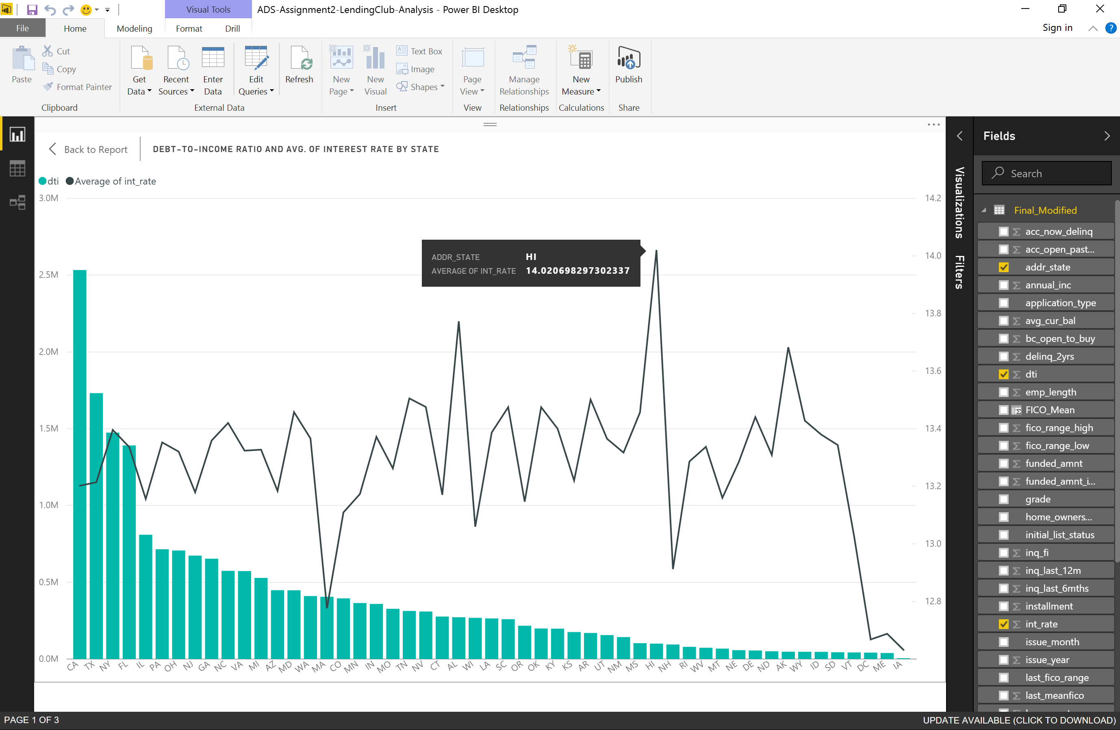

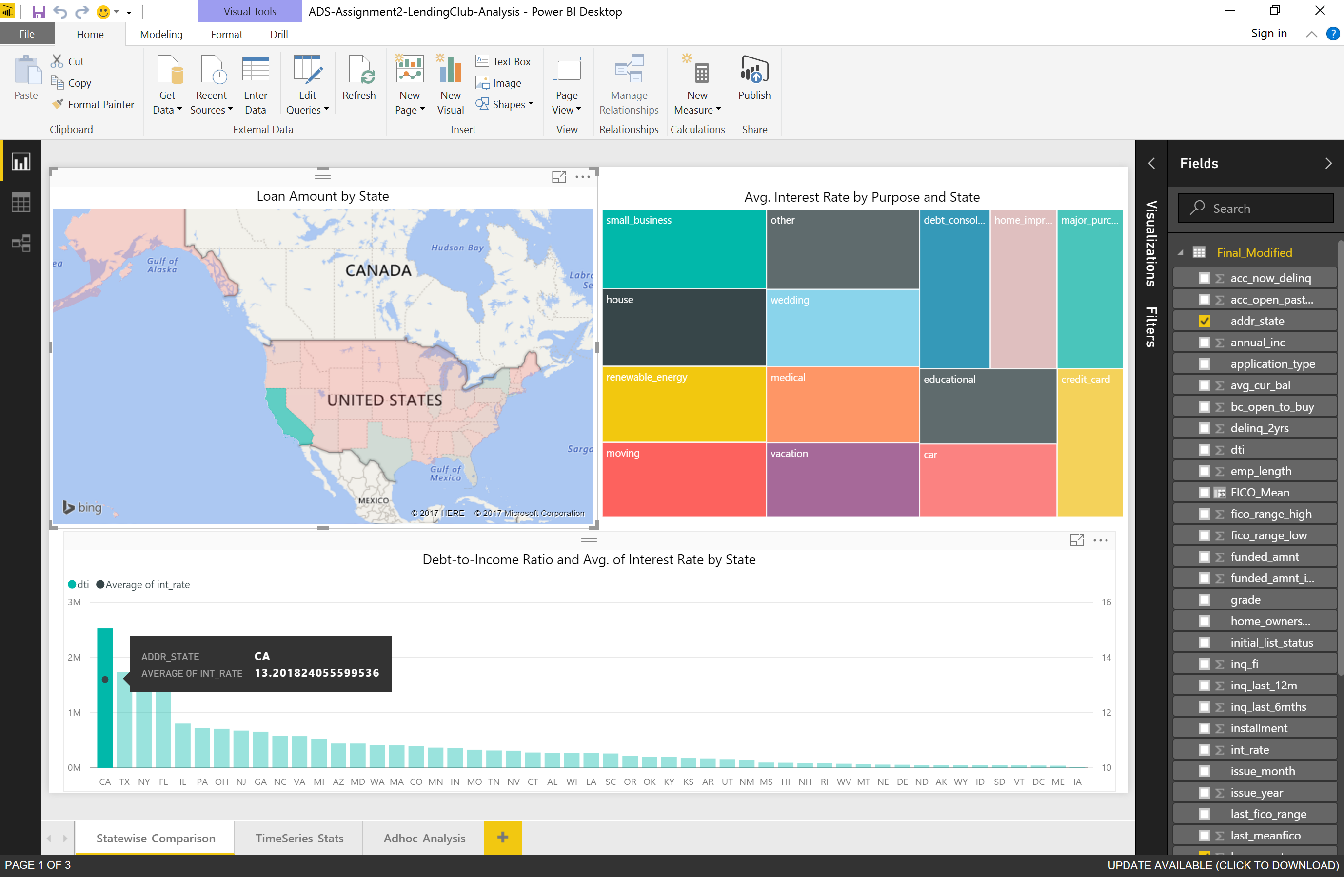

**TIME-Series Stats**

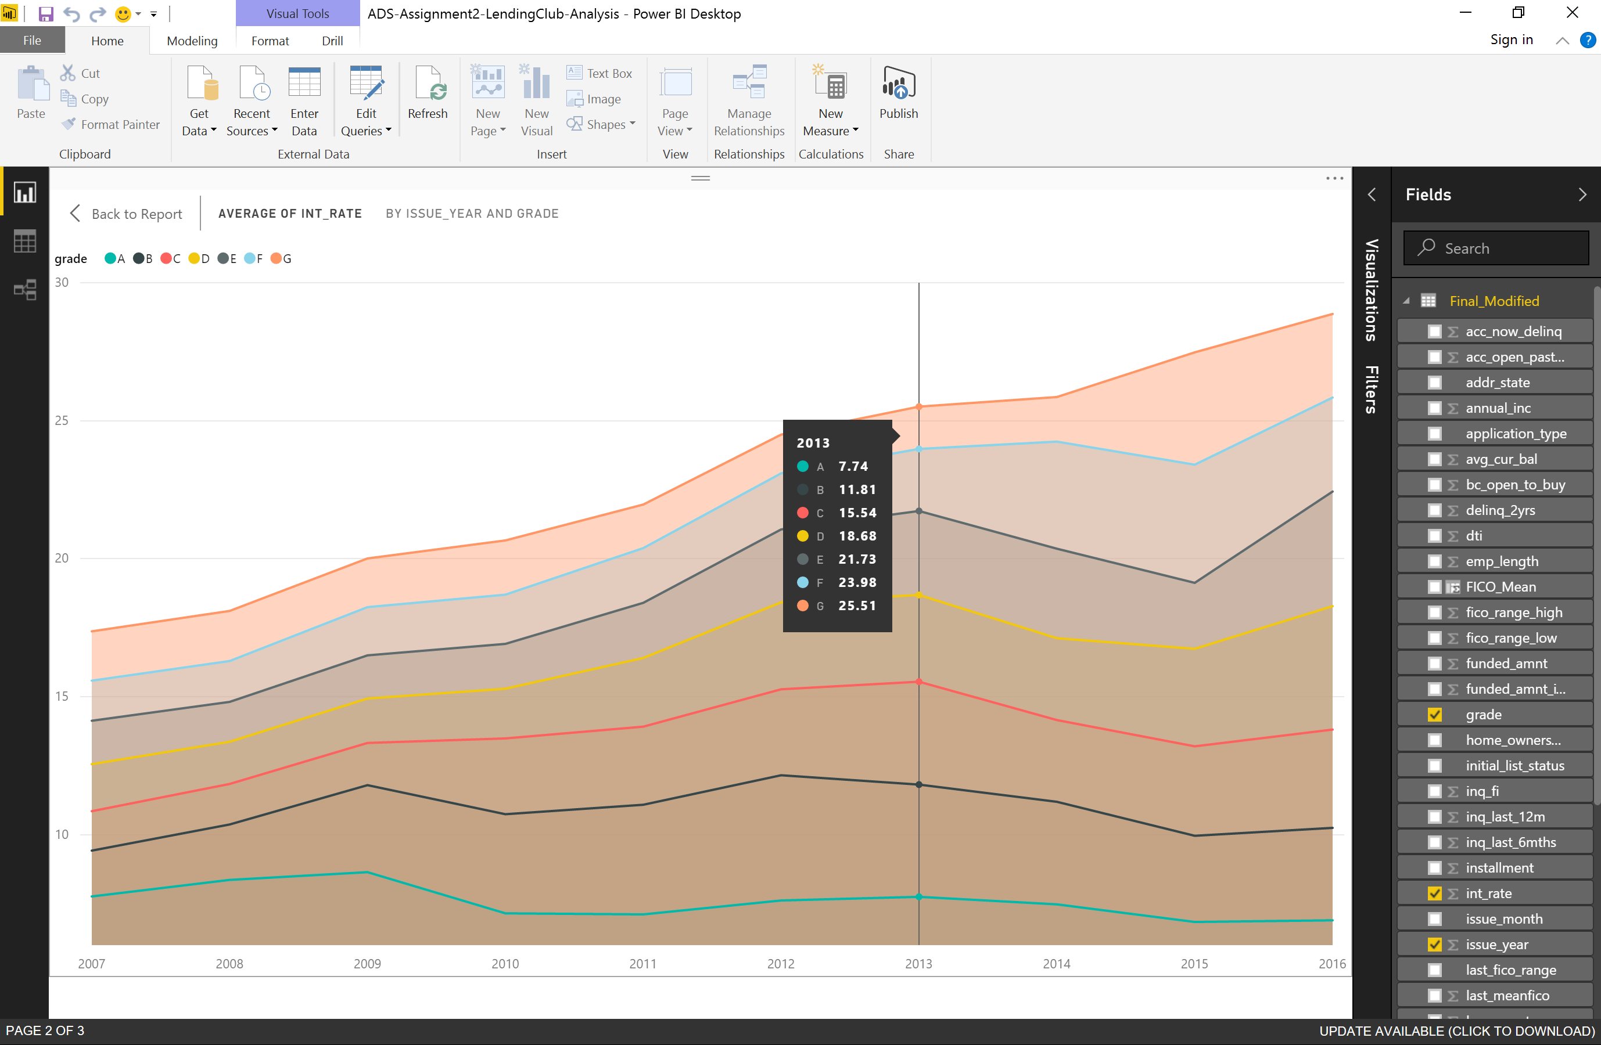

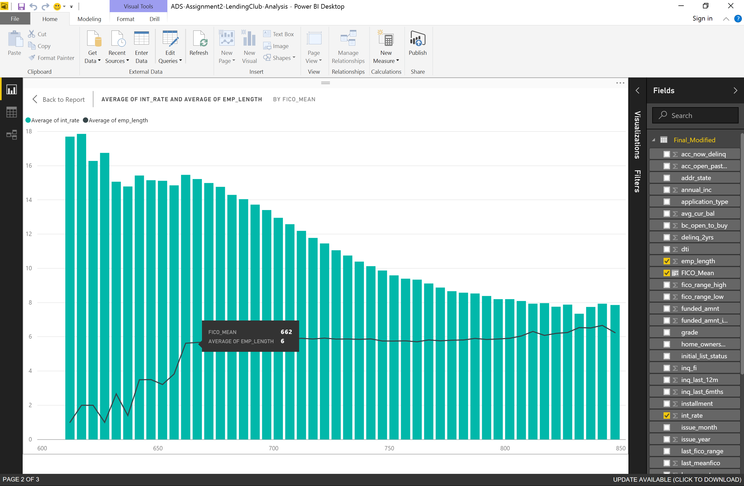

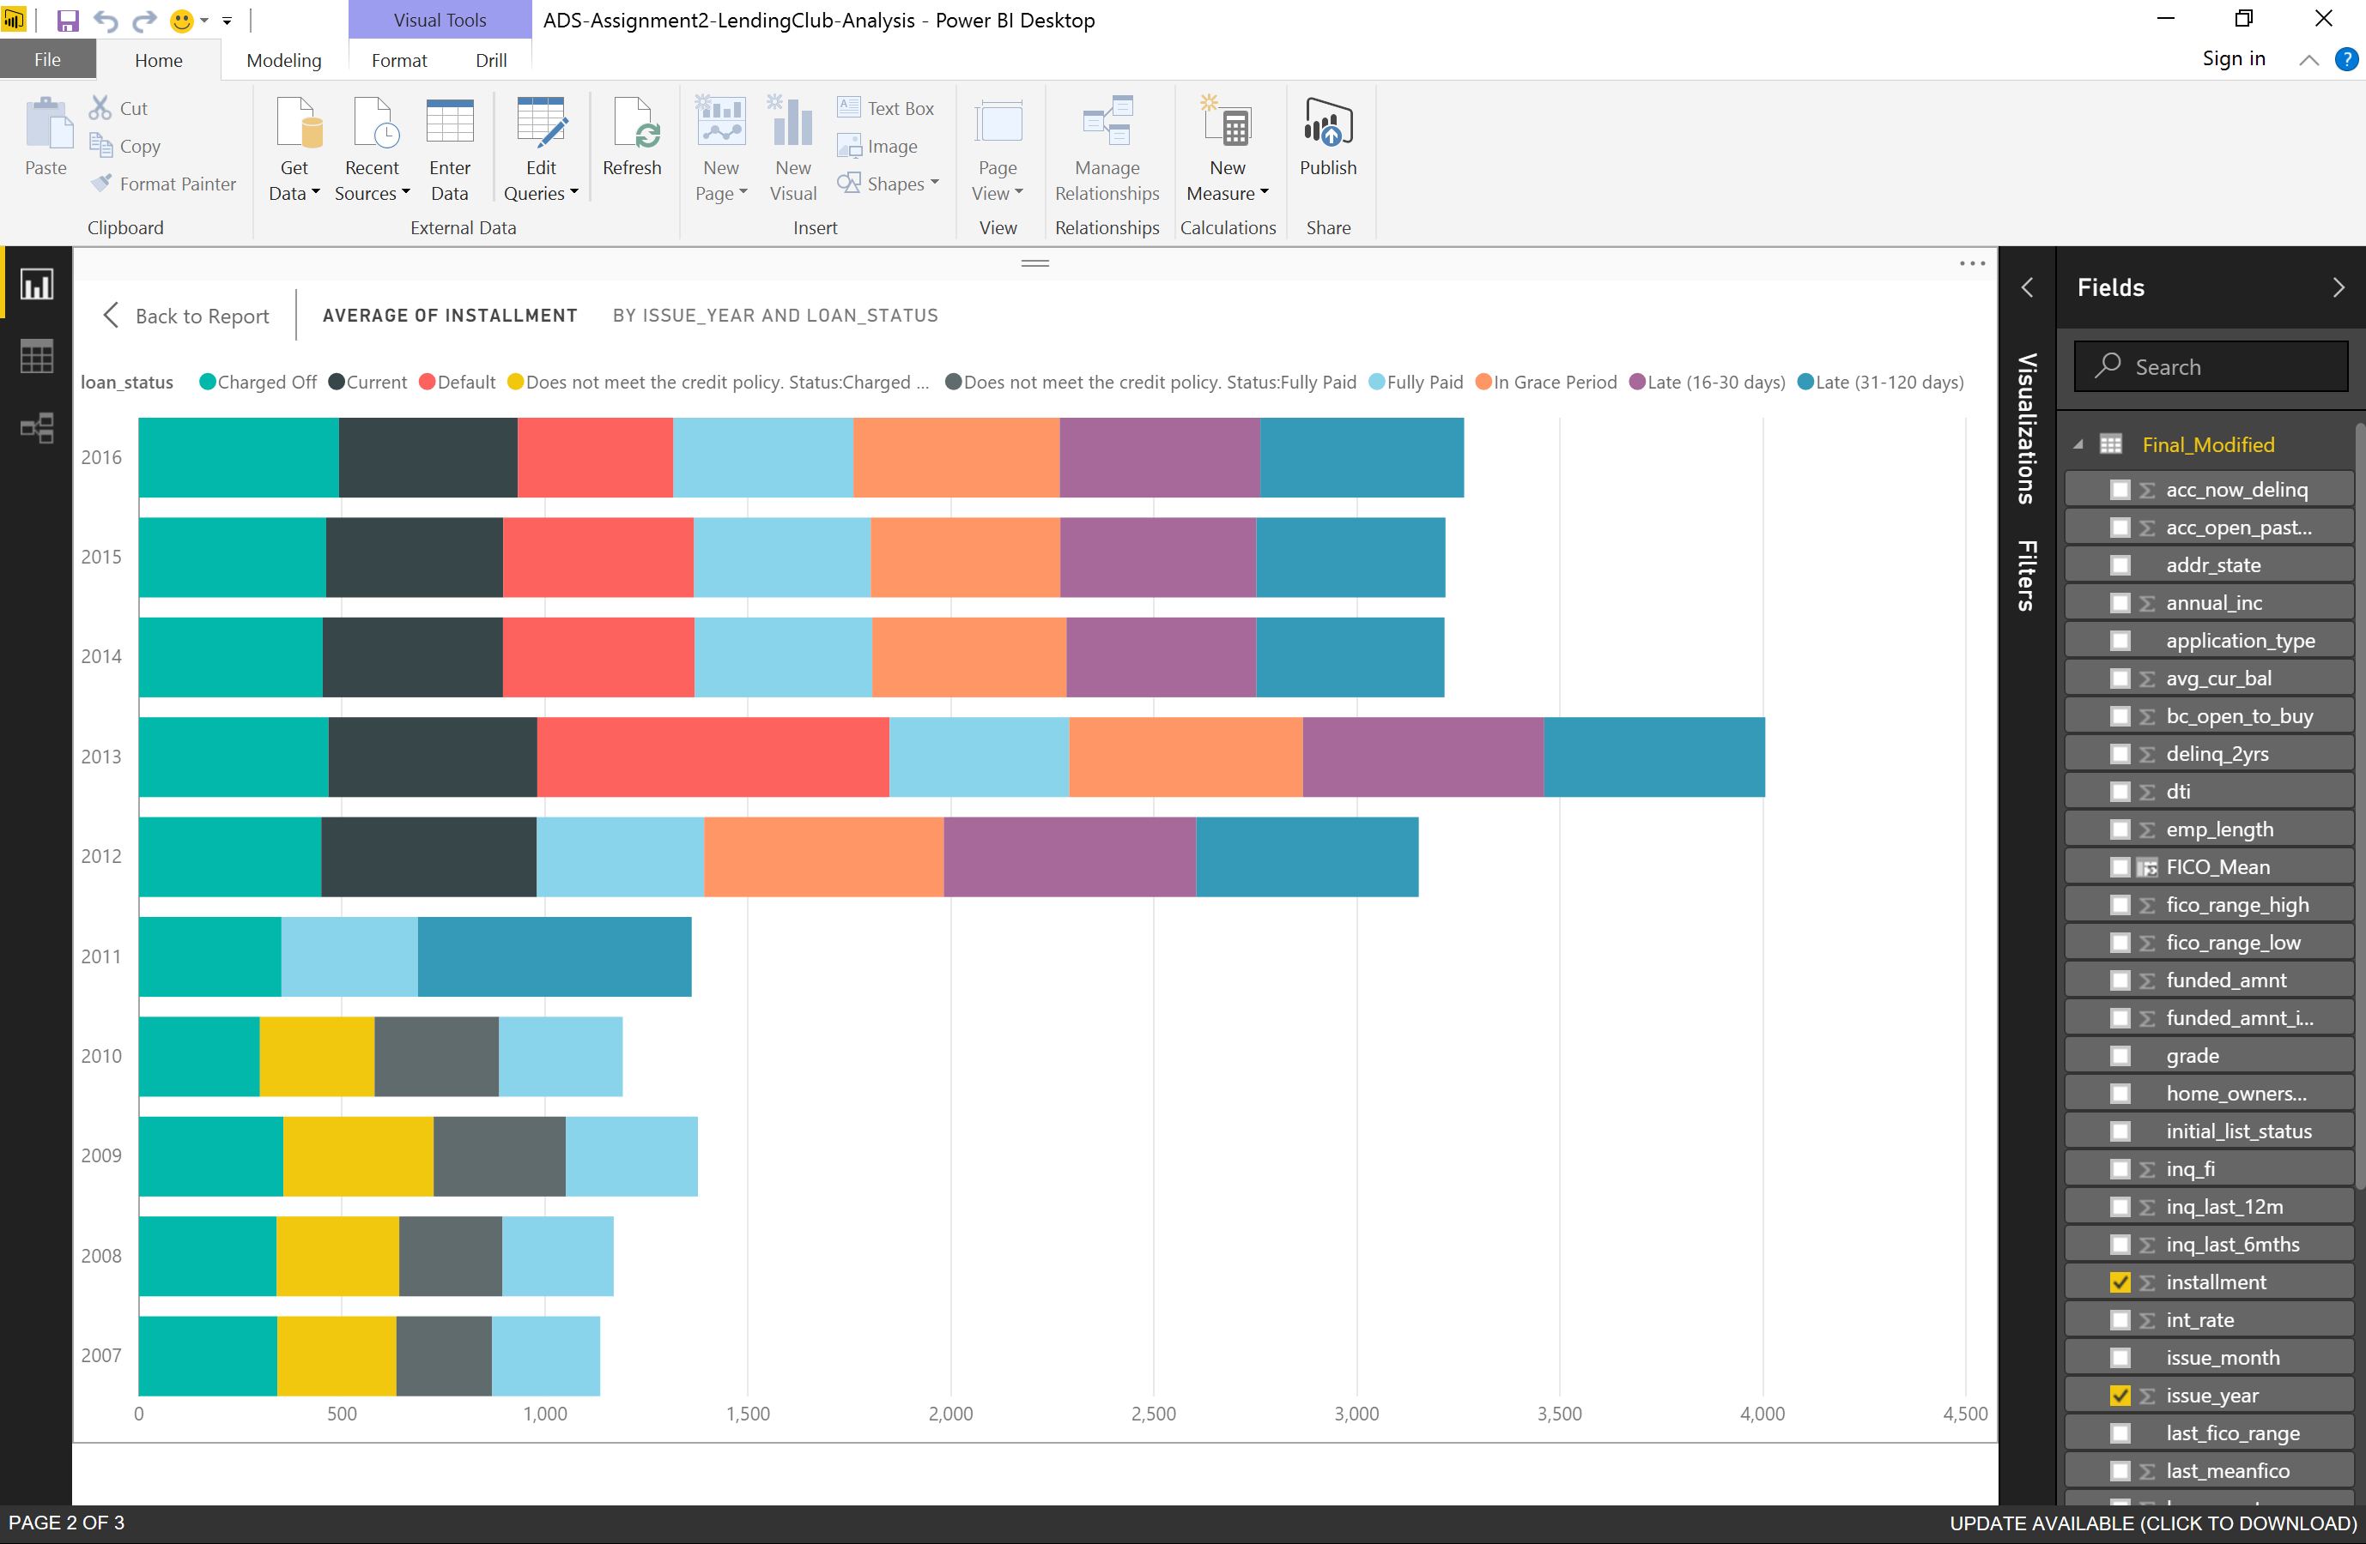

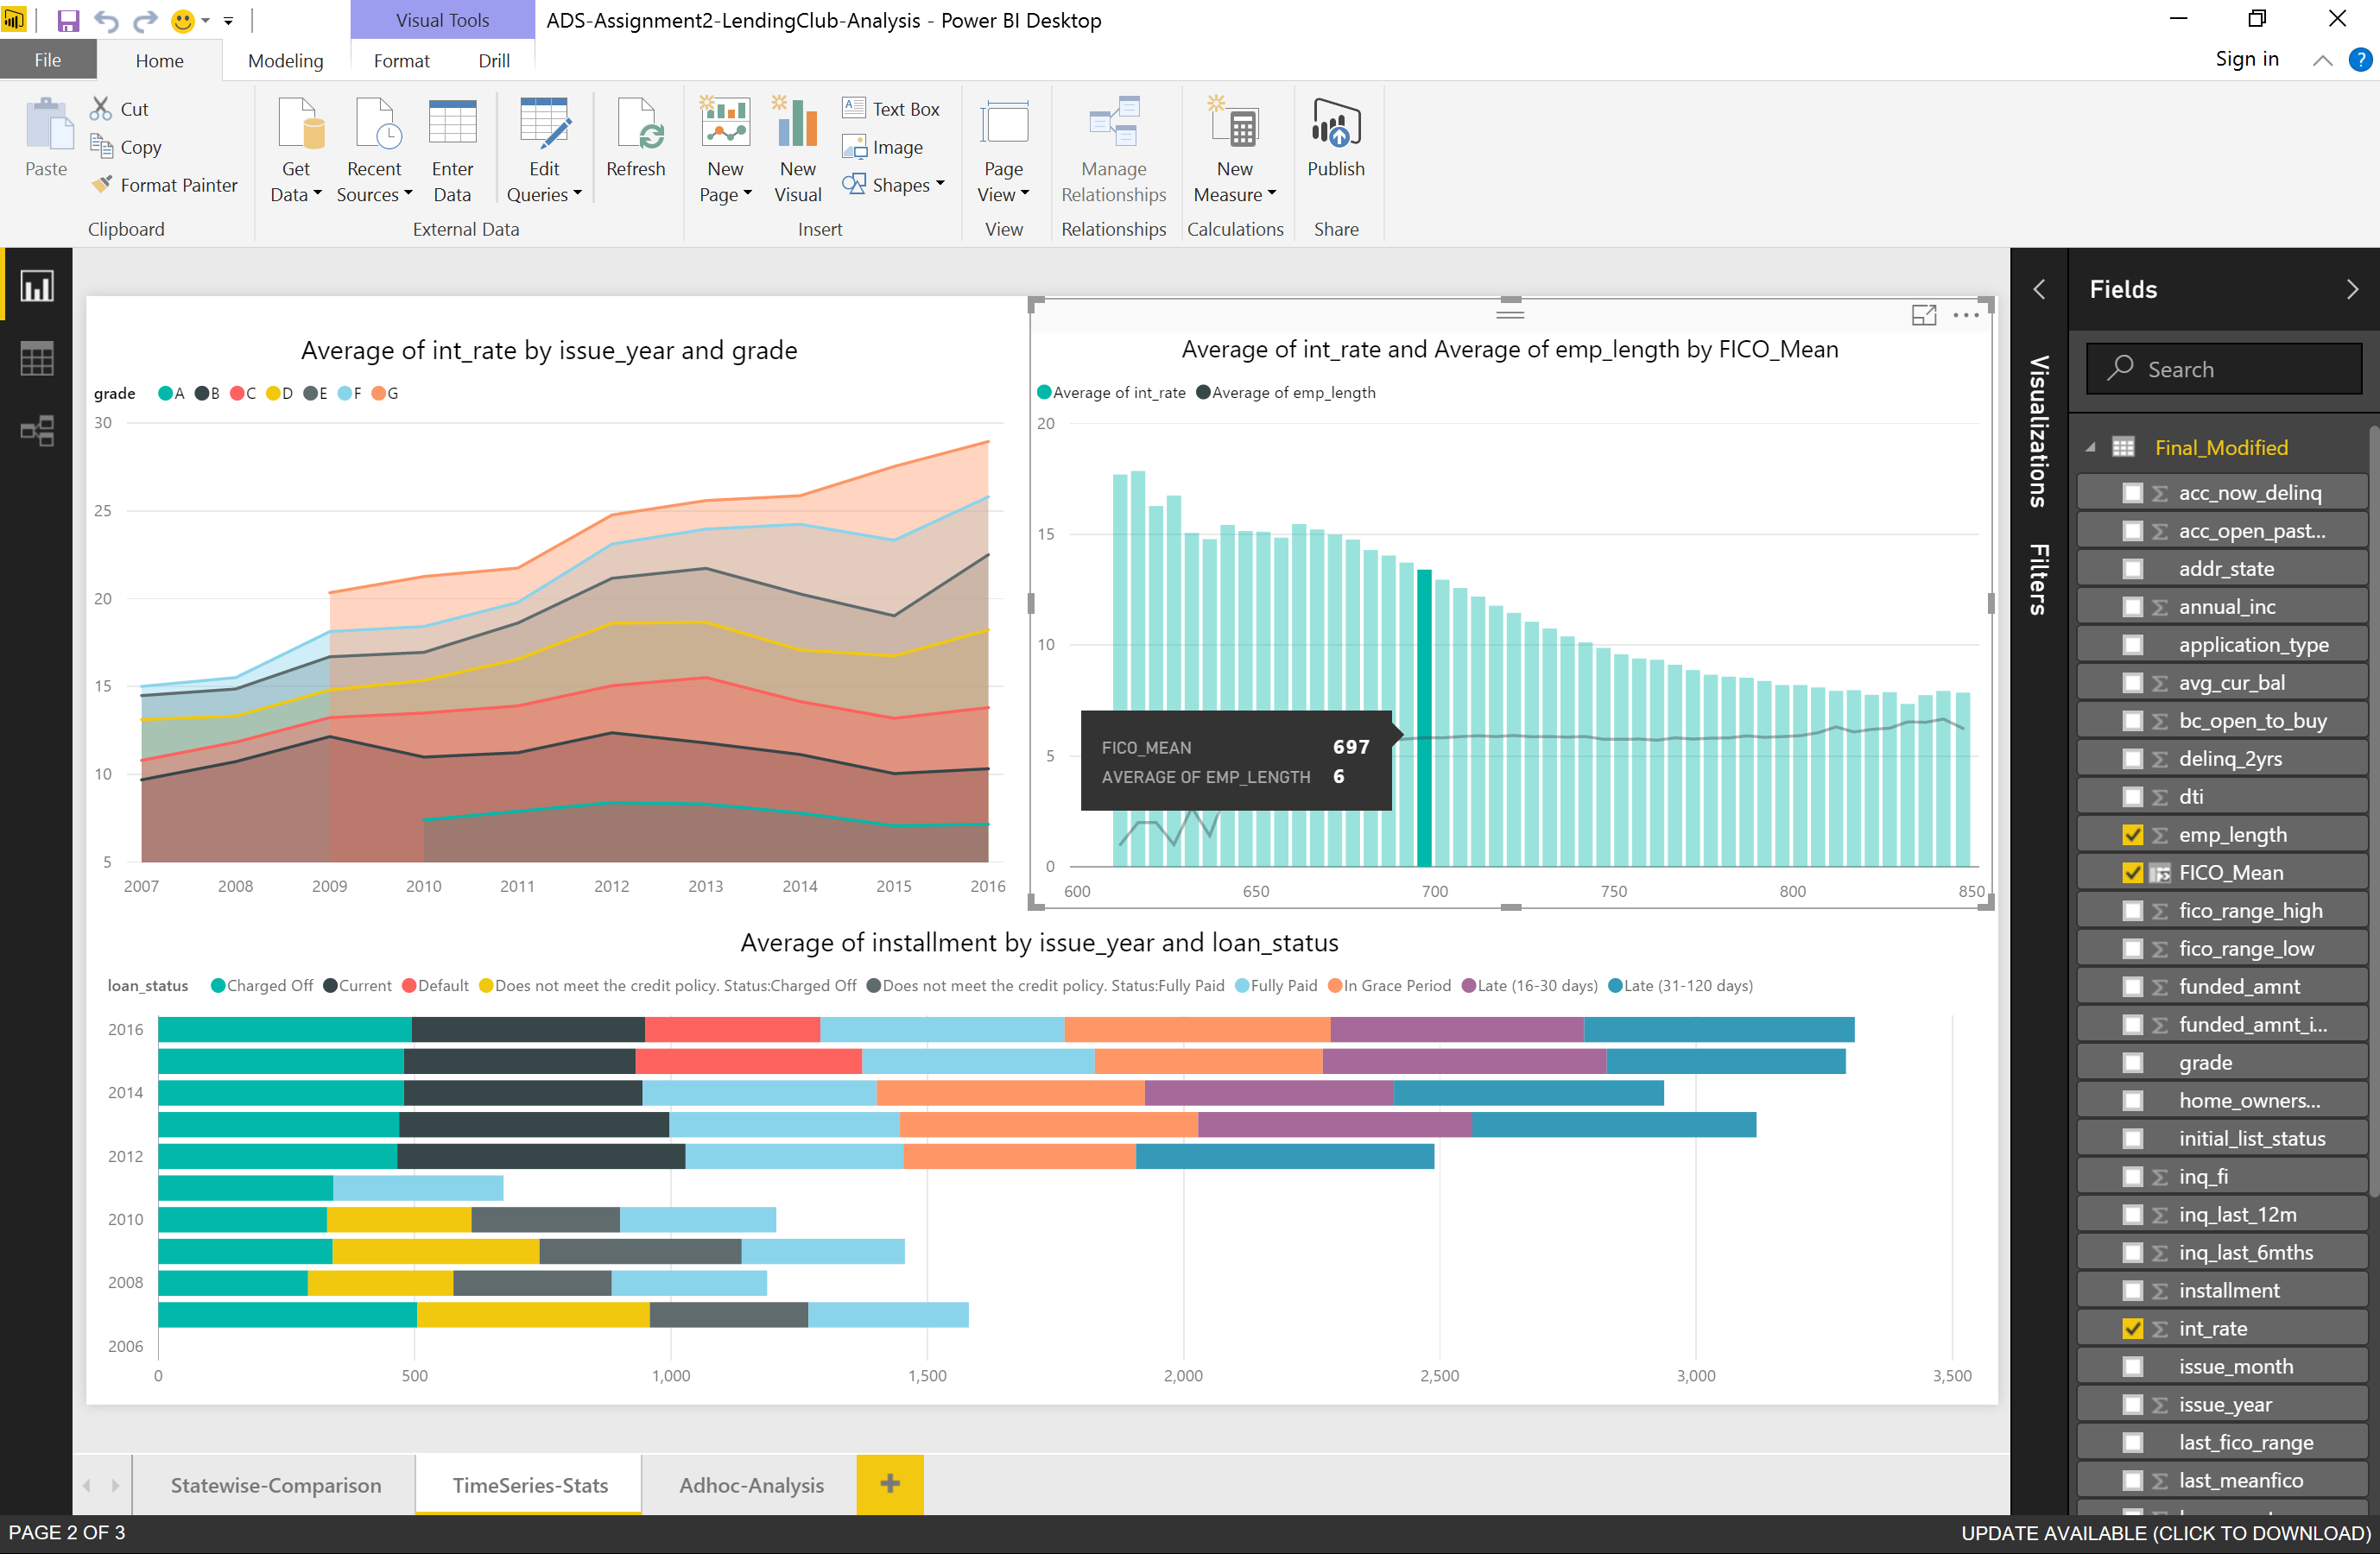

**ADHOC- Analysis**

